**­A MINOR PROJECT ON**

**“MULTI LAYER SECURITY INTEGRATION**

**BASED ON SIEM SOLUTION”**



**Submitted by:**

|  |  |
| --- | --- |
| **Nirmal Adhikari**  **Sujal Lamichhane**  **Ujjwal Kandel** | **[230021]**  **[230024]**  **[230026]** |

**Submitted to:**

**Department of BCS (NT & CS)**

**Forbes College**

**Bharatpur-2, Kshetrapur**

**November 16th, 2025**

# ACKNOWLEDGEMENT

We have put sincere effort into completing this project, but it would not have been possible without the guidance, encouragement and support of several individuals and our institute. We would like to express our heartfelt gratitude to our respected Principal, **Mr. Hari Saran Pathak** and our Vice-Principal, **Mr. Yogendra Mandal**, of Forbes College for providing us with the opportunity and resources to carry out this work. We also extend our sincere thanks to the respected Head of Department, **Er. Raj Kumar Sapkota**, for his continuous motivation and support throughout the project journey.

We are deeply indebted to our honorable supervisor, **Mr. Anuj Khanal**, whose invaluable guidance, insightful suggestions, and constant supervision played a crucial role in the successful completion of this project. His encouragement and expertise helped us overcome challenges and provided us with the confidence to move forward.

Finally, we would like to thank all our respected teachers and classmates for their cooperation, encouragement and constructive feedback, which greatly contributed to the accomplishment of this project.

# EXECUTIVE SUMMARY

In today’s rapidly evolving cybersecurity landscape, detecting, analyzing, and responding to threats in real time is essential for protecting organizational assets. This project presents a multi-layer intrusion detection and security monitoring environment built using pfSense, Suricata, Wazuh SIEM, and VirusTotal integration. It simulates and analyzes cyberattacks in a controlled lab setting, demonstrating how layered defenses improve visibility and response. The core design connects pfSense, an open-source firewall and gateway, with Suricata, a high-performance intrusion detection and prevention engine that inspects all inbound and outbound traffic for malicious activity such as scans, brute-force attempts, and exploit signatures. Detected events are forwarded to Wazuh, an open-source SIEM that centralizes log collection, correlation, and real-time alerting. To extend malware detection, suspicious file hashes are automatically sent to VirusTotal, which compares them against its global threat intelligence database, adding another layer of verification. Attack simulations from a Kali Linux machine against vulnerable systems included reconnaissance, exploitation, reverse shells, and privilege escalation. Wazuh successfully correlated Suricata alerts and host-based logs, providing detailed insights into attack timelines, source IPs, and affected endpoints. This architecture demonstrates the effectiveness of combining firewalling, network monitoring, endpoint detection, and external threat intelligence under a unified SIEM. By leveraging open-source technologies, the project ensures cost-effectiveness, scalability, and real-world applicability for small to medium-sized enterprise networks. Ultimately, it emphasizes the importance of layered security, centralized visibility, and rapid incident response in building modern cybersecurity defense strategies.

**Key Words:** SIEM, Kali Linux, Reverse shells, IPS, Exploitations, pfSense, Suricata, Wazuh, Port

TABLE OF CONTENTS

ACKNOWLEDGEMENT i

EXECUTIVE SUMMARY ii

LIST OF FIGURES v

LIST OF TABLES ix

CHAPTER 1: INTRODUCTION 1

1.1 Background 1

1.2 Problem Statement 1

1.3 Objectives 2

1.4 Products and Service Requirements 3

CHAPTER 2: LITERATURE REVIEW 5

CHAPTER 3: METHODOLOGY 6

3.1 Network Architecture 6

3.2 Working Flow 7

3.3 Flowchart 9

3.4 Environmental Setup 10

3.4.1 Installing VMware Workstation Pro 10

3.4.2 Creating Virtual Machines 11

3.5 Installation and Configuration of pfSense Firewall 13

3.5.1 Configuring Nat: Outbound rule 19

3.5.2 LAN Rule 20

3.5.3 WAN Rule 21

3.5.4 Suricata Installation and Configuration on pfSense 22

3.5.5 Snort Rules Installation and Configuration on pfSense 28

3.6 Installation and Configuration of Wazuh Server in Ubuntu 30

3.6.1 VirusTotal Integration 32

3.7 Installing Wazuh Agent in pfSense 35

3.7.1 Confirm pfSense Wazuh Agent Status on Wazuh Manager 39

3.8 Installing Wazuh Agent in Windows (Vulnerable System) 39

3.9 Alerting and Notification 41

3.9.1 Testing SMTP Server 44

CHAPTER 4: EPILOUGE 46

4.1 Outcome 46

4.2 Time Schedule 46

4.3 Budget Analysis 47

CHAPTER 5: CONCLUSION 48

CHAPTER 6: LIMITATIONS AND FUTURE WORKS 49

6.1 Limitations 49

6.2 Enhancements 50

REFERENCE 51

# 

# LIST OF FIGURES

Figure 1. 1: pfSense 3

Figure 1. 2: Suricata 3

Figure 1. 3: Wazuh Agent 4

Figure 1. 4: Kali Linux 4

Figure 1. 5: Ubuntu 5

Figure 3. 1: Network Architecture 6

Figure 3. 2: Working Flow 7

Figure 3. 3: Flowchart 9

Figure 3. 4: VMware Workstation Download 10

Figure 3. 5: Selecting the Type of Configuration 11

Figure 3. 6: Choosing the Installer Disc Image File 12

Figure 3. 7: Naming the Virtual Machine 12

Figure 3. 8: Customizing the Hardware for the Guest OS 13

Figure 3. 9: Starting pfSense in VMware 14

Figure 3. 10: Installing pfSense 14

Figure 3. 11: Selecting The WAN Interface 15

Figure 3. 12: Proceeding With The Installation 15

Figure 3. 13: Rebooting after the installation of pfSense completes 16

Figure 3. 14: Welcome Screen After Successful Rebooting 16

Figure 3. 15: Confirming the interface configuration in the pfSense initial configuration 17

Figure 3. 16: Configuring LAN Interface 17

Figure 3. 17: pfSense Login Page 18

Figure 3. 18: Changing Default Admin Password 18

Figure 3. 19: Selecting the Outbound NAT Mode as Hybrid 19

Figure 3. 20: Configuring the Outbound NAT Policy 19

Figure 3. 21: Selecting the Protocol, Source and Destination 20

Figure 3. 22: Saving the Changes 20

Figure 3. 23: LAN Rule 21

Figure 3. 24: Configuring WAN Rule 21

Figure 3. 25: Accessing the Package Manager to Find Suricata 22

Figure 3. 26: Installing Suricata 22

Figure 3. 27: Navigating Suricata in the Services Tab 23

Figure 3. 28: Choosing the WAN Interface 23

Figure 3. 29: Logging Settings 24

Figure 3. 30: Selecting the Required EVE Output Settings 24

Figure 3. 31: Enabling Promiscuous Mode 25

Figure 3. 32: Selecting the Rule Sets 25

Figure 3. 33: Updating the Rule Set 26

Figure 3. 34: Activating the Suricata 26

Figure 3. 35: Enabling the Required Rules 27

Figure 3. 36: Services 27

Figure 3. 37: Snort Sign Up Page 28

Figure 3. 38: Snort Snapshot Rules 28

Figure 3. 39: Oinkcode 29

Figure 3. 40: Snort Rules Filename 29

Figure 3. 41: Selecting the Preferred Language 30

Figure 3. 42: Ubuntu OS Login Page 30

Figure 3. 43: Installing packages 31

Figure 3. 44: Wazuh Server Login Page 31

Figure 3. 45: Wazuh Dashboard 32

Figure 3. 46: VirusTotal API Key 32

Figure 3. 47: Integration 33

Figure 3. 48: File Integrity Monitoring setup 33

Figure 3. 49: Wazuh Integrity Monitoring 33

Figure 3. 50: Detected file shown in Wazuh Dashboard 34

Figure 3. 51: Files Detected in the Directory 34

Figure 3. 52: VirusTotal Detection 34

Figure 3. 53: SSH connection to pfSense 35

Figure 3. 54: Editing the pfSense.conf File 35

Figure 3. 55: Enabling the FreeBSD 36

Figure 3. 56: Updating the Package Repository 36

Figure 3. 57: Checking the Wazuh-Agent Version 36

Figure 3. 58: Editing and Setting Wazuh Manager IP 37

Figure 3. 59: Enabling and Starting Wazuh Agent 37

Figure 3. 60: Opening pfSense.conf File using Nano 38

Figure 3. 61: Opening FreeBSD.conf File using Nano 38

Figure 3. 62: Disabling FreeBSD Official Repositories 38

Figure 3. 63: Cleaning Package Catalog 38

Figure 3. 64: Confirming Wazuh Agent Status in Manager 39

Figure 3. 65: Downloading Wazuh Agent 39

Figure 3. 66: Executing the Command to Install the Package 40

Figure 3. 67: Starting the Wazuh Agent Service 40

Figure 3. 68: Agent Successfully Connected to the Manager 40

Figure 3. 69: Suricata alerts in Wazuh Dashboard 41

Figure 3. 70: Installing Postfix and Mailutils Packages 41

Figure 3. 71: Selecting Internet Site 42

Figure 3. 72: Opening main.cf File Using Nano 42

Figure 3. 73: Editing main.cf File 42

Figure 3. 74: Setting the Email and Password 43

Figure 3. 75: Securing the Email Password 43

Figure 3. 76: Test email from wazuh server 44

Figure 3. 77: Configuring ossec.conf file 45

Figure 3. 78: Sample Alert 45

# LIST OF TABLES

Table 4. 1: Time Schedule 46

Table 4. 2: Budget Analysis 47

|  |  |
| --- | --- |
| ABBREVATIONS | DEFINITIONS |
| HIDS | Host-based Intrusion Detection System |
| IDS | Intrusion Detection System |
| IPS | Intrusion Prevention System |
| NSM | Network Security Monitoring |
| SIEM | Security Information and Event Management |
| SMEs | Small and Medium-sized Enterprises |
| SOC | Security Operations Center |
| VM | Virtual Machine |
| XDR | Extended Detection and Response |

**LIST OF ACRONYMS**

# CHAPTER 1: INTRODUCTION

## Background

The ever-growing dependence on digital infrastructure in modern organizations had led to an exponential increase in the frequency and complexity of cyber threats. From small businesses to large enterprises, no entity was immune to risks such as malware infections, phishing attacks, unauthorized access, and data breaches. As attack vectors became more sophisticated, traditional security mechanisms were no longer sufficient to defend against advanced threats. This necessitated the integration of proactive and reactive security measures, such as real-time threat detection, intrusion prevention, and centralized monitoring. In this context, open-source technologies had emerged as viable and powerful alternatives to expensive proprietary solutions. Tools such as pfSense, Suricata, and Wazuh offered robust capabilities in network traffic filtering, intrusion detection, and security information and event management (SIEM), respectively. When integrated properly, these tools could provide a cost-effective, scalable, and customizable security infrastructure suitable for educational, research, and enterprise environments. pfSense acted as the primary firewall, managing network segmentation and access control. Suricata, a high-performance IDS/IPS engine, inspected traffic for signs of malicious behavior and generated alerts based on rule-based threat signatures. These alerts, along with logs from other endpoints, were sent to Wazuh, which provided SIEM functionalities such as log analysis, threat correlation, alert, and incident visualization through dashboards. This project sought to harness these technologies to simulate a real-world cybersecurity environment where attacks were actively launched and detected. It aimed to demonstrate how a layered defense approach could enhance visibility, detection, and response capabilities—an essential requirement for any modern security operations center (SOC).

## 1.2 Problem Statement

Despite increased awareness of cybersecurity risks, many organizations, especially small to medium-sized enterprises (SMEs) and academic institutions—struggle to implement effective threat detection and monitoring systems. Key issues include:

1. **Lack of Real-Time Threat Visibility:** Many networks operate without real-time monitoring, allowing attacks such as brute-force, port scanning, or privilege escalation to go undetected.
2. **High Cost of Commercial Security Solutions:** Enterprise-grade SIEM, IDS/IPS, and firewall solutions often require significant financial investment, making them inaccessible to smaller organizations and students.
3. **Fragmented Security Systems:** In many cases, network defenses consist of isolated components (e.g., firewall, antivirus, logging tools) that do not communicate, resulting in weak correlation and delayed incident response.
4. **Limited Hands-On Learning Environments:** Educational institutions often lack realistic cybersecurity lab environments for students to practice attack detection, analysis, and incident response.
5. **Overreliance on Signature-Based Detection:** Traditional detection systems may fail to identify zero-day or polymorphic attacks due to dependence on outdated or limited rule sets.
6. **Insufficient Log Management and Correlation:** Logs generated by network and host systems are often underutilized due to the absence of centralized collection and analysis mechanisms.

## Objectives

The primary objectives of this project are as follows:

1. Design and implement a secure network environment using open-source tools like pfSense, Suricata, and Wazuh to emulate enterprise-level security operations.
2. Deploy Suricata as an IDS/IPS to monitor network traffic and detect threats such as port scans, brute-force attempts, and known exploits.
3. Integrate Wazuh as a centralized SIEM to collect, correlate, and analyze logs from both network and endpoint sources.
4. Simulate real-world cyberattacks using a Kali Linux attacker machine to test the effectiveness of detection and response mechanisms.
5. Establish centralized logging and alerting, enabling real-time visibility and streamlined incident response.
6. Demonstrate layered security by combining network-level and host-based detection, showcasing a comprehensive defense strategy.

## Products and Service Requirements

1. **pfSense Firewall Appliance:** A free, open-source firewall and router distribution based on FreeBSD. pfSense provides enterprise-grade features such as NAT, VLANs, DHCP, DNS, and VPN support. In this project, pfSense is deployed as a virtual or physical appliance and serves as the perimeter security device, integrating with Suricata for network-level intrusion detection and traffic inspection [1].

Figure 1. : pfSense

Figure 1. : SuricataFigure 1. : pfSense

1. **Suricata IDS/IPS Software:** An open-source, high-performance network threat detection engine capable of real-time intrusion detection (IDS), intrusion prevention (IPS), and network security monitoring (NSM). Installed as a package in pfSense, Suricata operates in IDS mode to analyze packets, generate alerts on suspicious traffic patterns, and forward logs for correlation in Wazuh [2].

Figure 1. : Suricata

Figure 1. : Wazuh AgentFigure 1. : Suricata

1. **Wazuh Manager and Dashboard:** A comprehensive open-source Security Information and Event Management (SIEM) platform. It provides threat detection, integrity monitoring, log analysis, and incident response capabilities. Wazuh collects and correlates logs from both the network (Suricata) and host-level agents, displaying security events in its built-in web dashboard. It includes rule sets, decoders, and active responses to automate threat mitigation.
2. **Wazuh Agent Software:** Lightweight agents installed endpoint machines (Windows/Linux) to monitor system activity, perform file integrity checks, collect audit logs, and report to the Wazuh Manager. These agents help provide host-based intrusion detection (HIDS) and full endpoint visibility for real-time alerting and correlation [3].

Figure 1. : Wazuh Agent

Figure 1. : Kali LinuxFigure 1. : Wazuh Agent

1. **Kali Linux Virtual Machine:** An open-source, Debian-based Linux distribution specifically designed for penetration testing and ethical hacking. Kali Linux is used in the lab environment to simulate various attack vectors (e.g., brute-force, reverse shell, scanning, exploitation) to validate the detection and logging capabilities of the integrated system [4].

Figure 1. : Kali Linux

Figure 1. : UbuntuFigure 1. : Kali Linux

1. **Ubuntu/Windows Endpoints:** Generic operating system platforms used as victim machines for attack simulation. They are equipped with Wazuh agents and are targeted by Kali Linux to generate real-world security events. These machines help demonstrate the effectiveness of Wazuh’s detection capabilities [5].

Figure 1. : Ubuntu

# CHAPTER 2: LITERATURE REVIEW

Intrusion Detection Systems (IDS) are crucial in cybersecurity for monitoring and identifying malicious activities within networks. Signature-based IDS, such as Snort, detect known threats using predefined patterns, providing effective protection against previously identified attacks [6]. In contrast, anomaly-based IDS analyze deviations from normal behavior to detect unknown threats, offering broader coverage against novel attacks [7]. However, both approaches have limitations when used individually, which has led to the development of hybrid IDS that combine signature- and anomaly-based methods to improve detection accuracy [8].

Modern security practices integrate IDS with Security Information and Event Management (SIEM) systems. SIEM platforms collect and analyze logs from across the network, improving visibility, enabling faster incident response, and supporting automated alerting and investigation [8].

The integration of multiple open-source tools into a layered SIEM-based system enhances security monitoring. pfSense, a firewall solution, provides network perimeter protection [9]. Wazuh provides host-level monitoring, collecting system logs and security events [10]. Together, these tools enable real-time detection, centralized log correlation, and comprehensive visibility.

Specifically, pfSense can be integrated with Wazuh to enhance monitoring capabilities. Heater explains that pfSense logs can be forwarded to the Wazuh manager using Filebeat and Syslog, enabling centralized analysis [9]. Kifarunix demonstrates how to install the Wazuh agent on pfSense, allowing the system to monitor activities and transmit logs securely to the manager [10].

Wazuh also offers a robust alert management system, which assigns severity levels, applies custom rules, and forwards alerts to external platforms or notification systems. These features support automated detection and response, improving overall network security [11].

# CHAPTER 3: METHODOLOGY

## 3.1 Network Architecture

Figure 3. 1: Network Architecture

This network architecture demonstrates a multi-layer security integration based on a SIEM solution, designed to enhance intrusion detection, monitoring, and incident response. Incoming internet traffic first passes through pfSense, which functions as a firewall and gateway, filtering and controlling access, while Suricata operates as an IDS/IPS to analyze traffic and detect potential threats at the network layer. Security events and logs from pfSense, Suricata, and internal endpoints such as the vulnerable system are collected by the Wazuh Agent and forwarded to the Wazuh Manager for centralized analysis and correlation. To strengthen malware detection, the system integrates VirusTotal, where suspicious file hashes are automatically compared against a large database of known malware signatures, providing an additional intelligence layer. If malicious activity is detected, the Wazuh Manager generates alerts and notifies the Admin through email, enabling real-time response. By combining network monitoring, host-level event collection, and external threat intelligence, this architecture provides a layered defense-in-depth strategy that ensures comprehensive visibility, accurate detection, and effective response to security incidents.

## 3.2 Working Flow

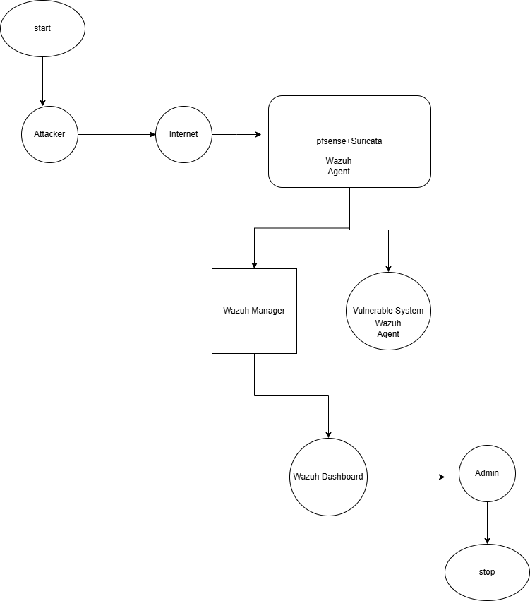

Figure 3. 2: Working Flow

This diagram illustrates the workflow of a security monitoring system using pfSense, Suricata, and Wazuh. An attacker initiates activity through the internet, which is first filtered by pfSense and inspected by Suricata for threats. A Wazuh Agent on this gateway captures relevant events. If the traffic reaches the vulnerable system, another Wazuh Agent monitors host-level activities. All collected data is sent to the Wazuh Manager, which analyzes and correlates events. The results are displayed on the Wazuh Dashboard, where the admin can review alerts and respond accordingly, ensuring effective threat detection and incident management.

## 3.3 Flowchart

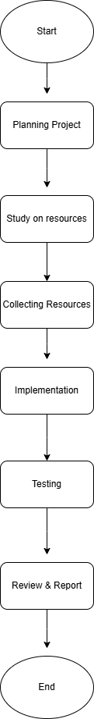

Figure 3. 3: Flowchart

## 3.4 Environmental Setup

This section explains how the virtual environment is configured to support the implementation of an integrated intrusion detection and security monitoring system using pfSense, Suricata, and Wazuh. The entire scenario is deployed using VMware Workstation Pro, where multiple virtual machines are created and connected through custom virtual networks to simulate realistic enterprise traffic and attack conditions.

### **3.4.1 Installing VMware Workstation Pro**

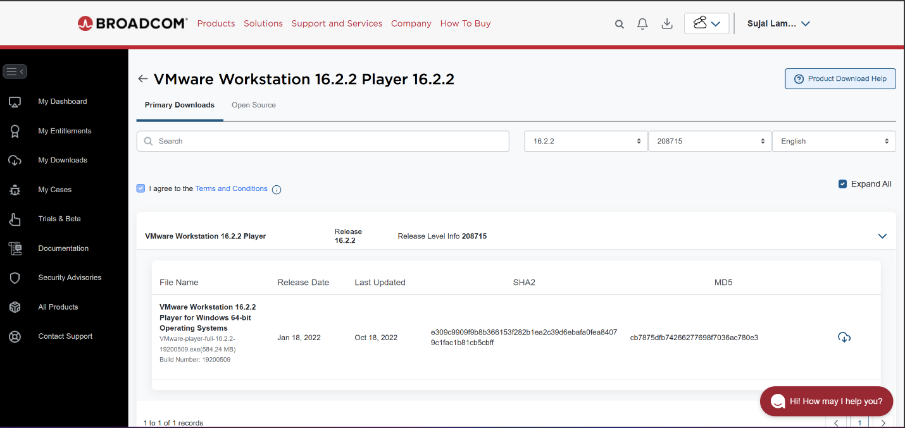The first step in setting up the lab environment is to install **VMware Workstation Pro** on a physical machine.

Figure 3. : VMware Workstation Download

VMware Workstation Pro was installed by downloading the installer from the official VMware website and running the setup using default settings. The license agreement was accepted, the default installation path was used, and the enhanced keyboard driver was enabled when prompted. After installation, VMware Workstation Pro was launched and activated as required.

### **3.4.2 Creating Virtual Machines**

After VMware is installed, the next step is to create virtual machines for each component of the architecture:

The process for creating a virtual machine in VMWare is same for all the VMs. So, follow same process to create virtual machines too.

Go to File > New Virtual Machine.

Then, Select “Typical (recommended)” and proceed.

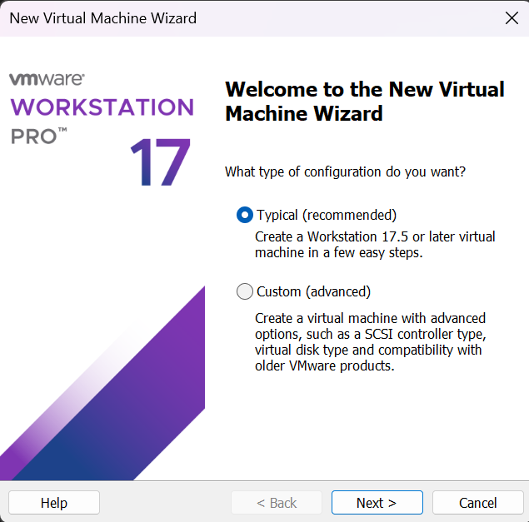

Figure 3. 5: Selecting the Type of Configuration

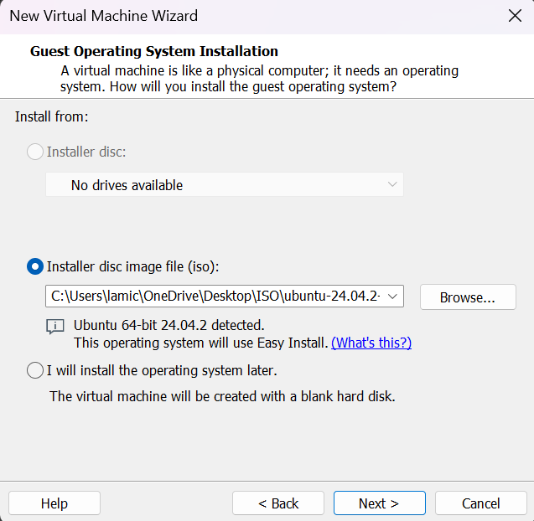Choose “Installer disc image file (ISO)” and browse to the ISO of the OS you want to install.

Figure 3. 6: Choosing the Installer Disc Image File

Then, provide the name to the Virtual Machine and Location. 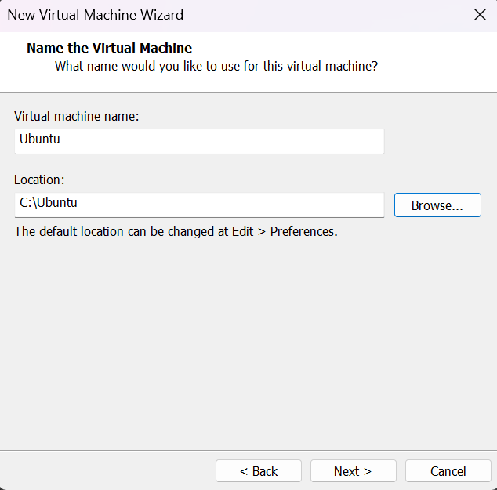

Figure 3. 7: Naming the Virtual Machine

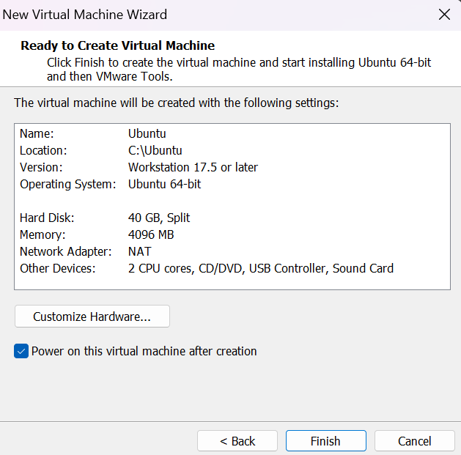Then, customize the guest OS as required and make sure to select the correct Network Adapter for that Virtual Machine which have been created.

Figure 3. 8: Customizing the Hardware for the Guest OS

Click on “Finish” and virtual machine has been created.

Do the same process for all the virtual machines according to the requirements.

## 3.5 Installation and Configuration of pfSense Firewall

Follow the steps mentioned above for creation of pfSense firewall. Open the Virtual Machine for pfSense Firewall, it takes some time to load.

As the pfSense setup starts booting, a prompt is displayed with some options and a countdown timer. At this prompt, press **1** for the default installation of pfSense. If any option is not choosen it will start to boot option 1 by default.

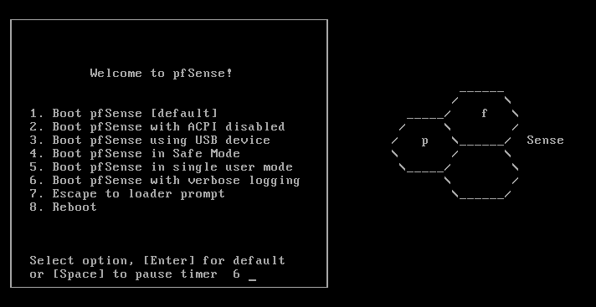

Figure 3. 9: Starting pfSense in VMware

Proceed with the **Install** option and select **OK**.

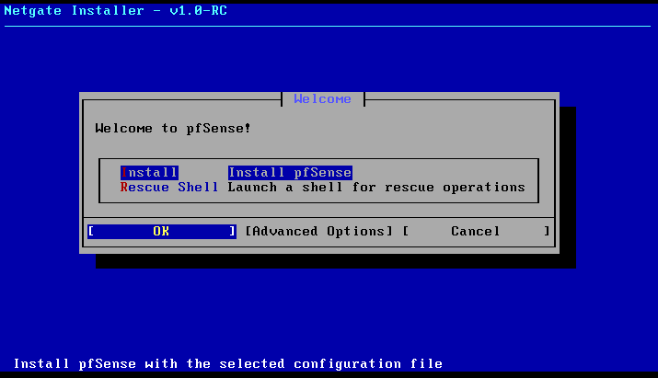

Figure 3. 10: Installing pfSense

Select the WAN Interface.

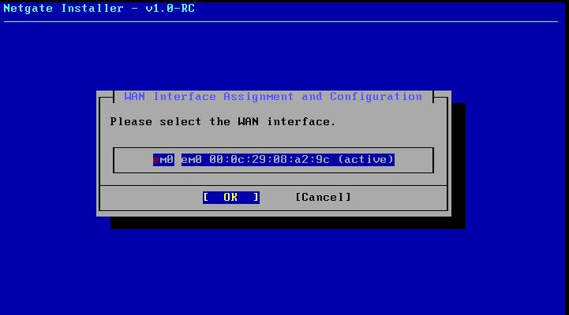

Figure 3. 11: Selecting The WAN Interface

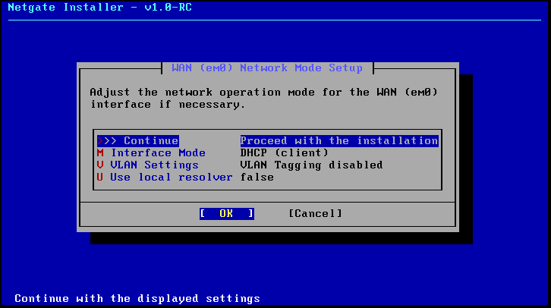Adjust the network operation mode for the WAN (eM0) interface if necessary. Else, proceed with the installation.

Figure 3. 12: Proceeding With The Installation

Follow the wizard.  It will take a few more minutes to complete the setup, obviously depends upon the system resources. Once, the installation process is completed, the following screen is shown.

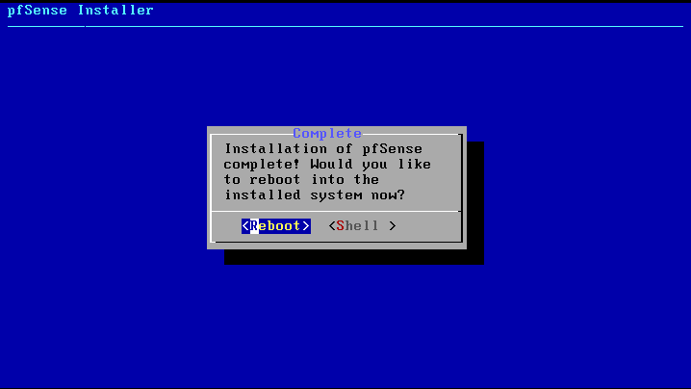Now, the firewall need to be rebooted by selecting the reboot option.

Figure 3. 13: Rebooting after the installation of pfSense completes

After clicking on the reboot button, we will find that the pfSense firewall is getting a reboot, we will get the pfSense Logo, and finally a Welcome screen the same as per the given image.

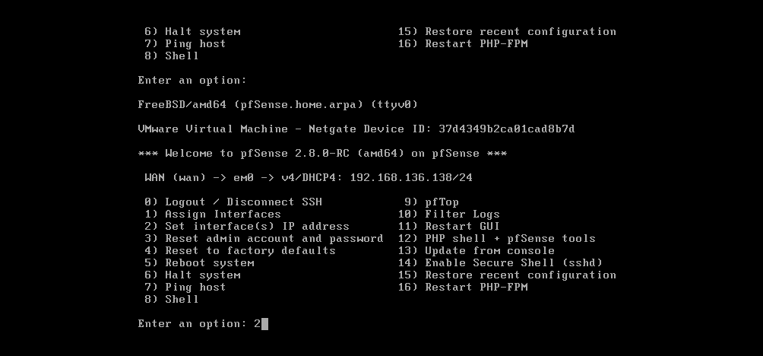

Figure 3. 14: Welcome Screen After Successful Rebooting

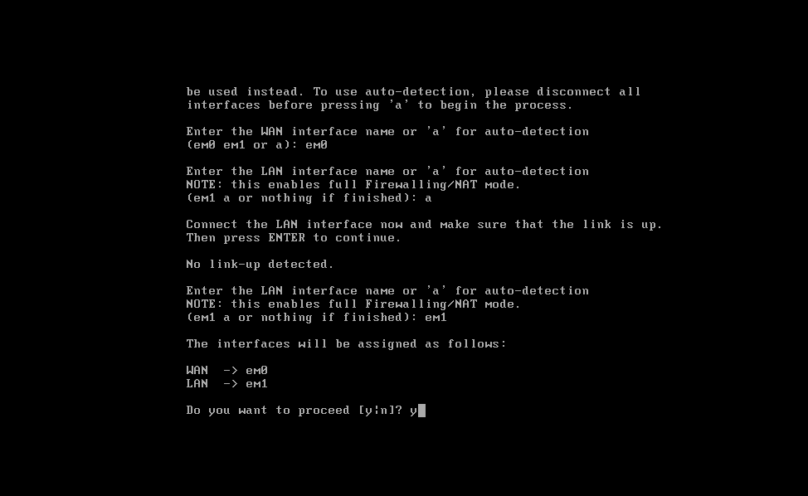After the installation of pfSense completes successfully, the virtual machine will boot into the initial configuration phase of the setup. In this text-only menu-driven interface, it will allow to configure the initial network configuration so we have connectivity to the pfSense VM.

Figure 3. : Confirming the interface configuration in the pfSense initial configuration

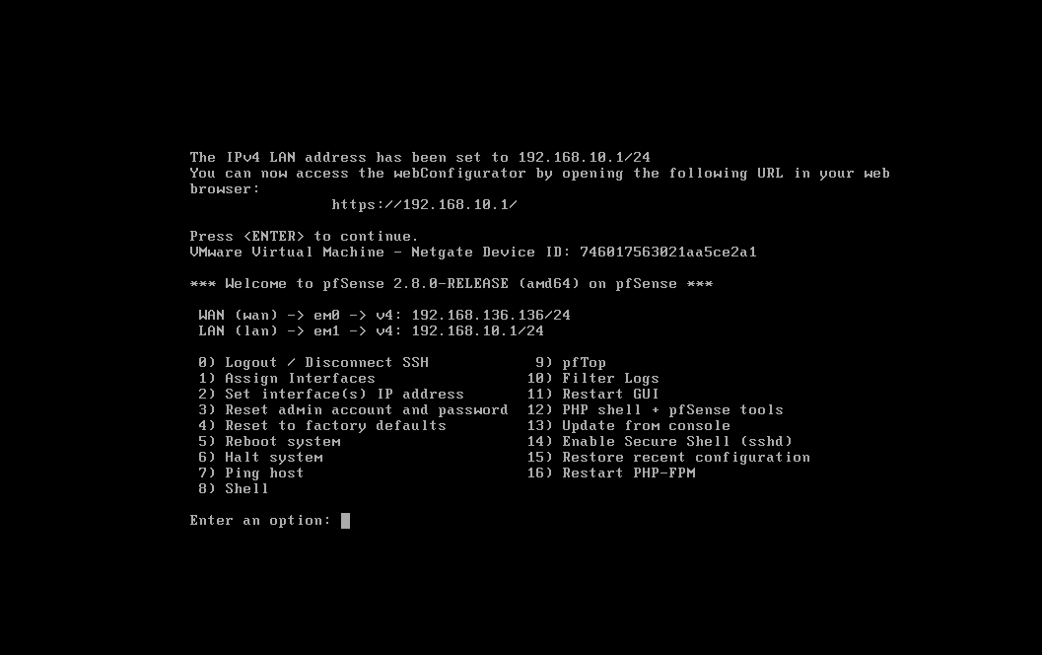Configure the LAN interface.

Figure 3. : Configuring LAN Interface

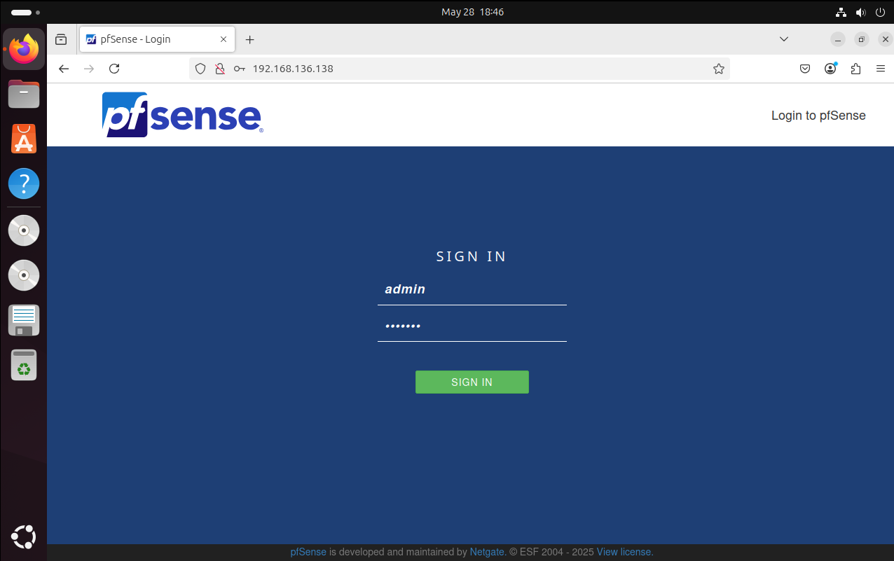Once pfSense reload, we will be able to access the webConfiguration @ <http://192.168.10.1/>. The default login user name is **admin** and the password is **pfsense**. pfSense setup wizard will guide through the initial configuration of pfSense.

Figure 3. : pfSense Login Page

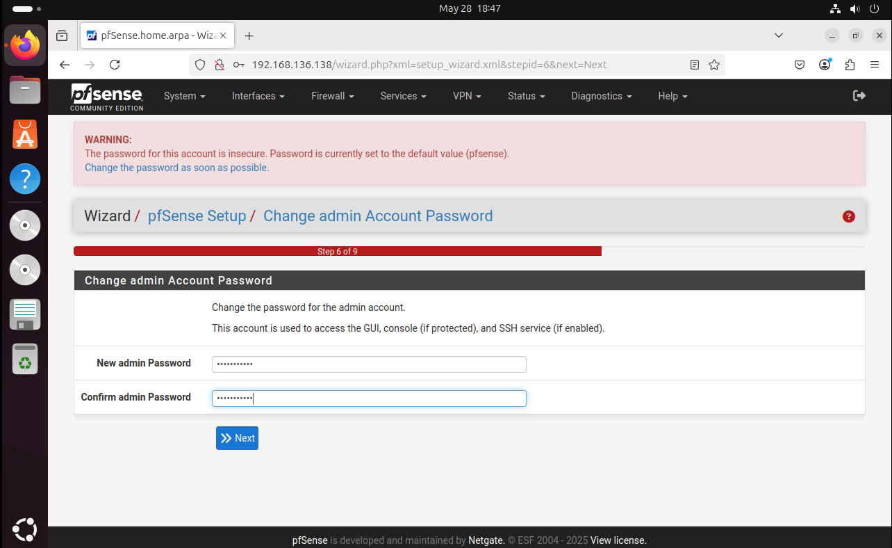After logging in, pfSense will prompt us to change the default admin password. Make sure to set a strong, secure password to protect the firewall.

Figure 3. : Changing Default Admin Password

### **3.5.1 Configuring Nat: Outbound rule**

1. Navigate to “Firewall” > “NAT” > “Outbound”.
2. 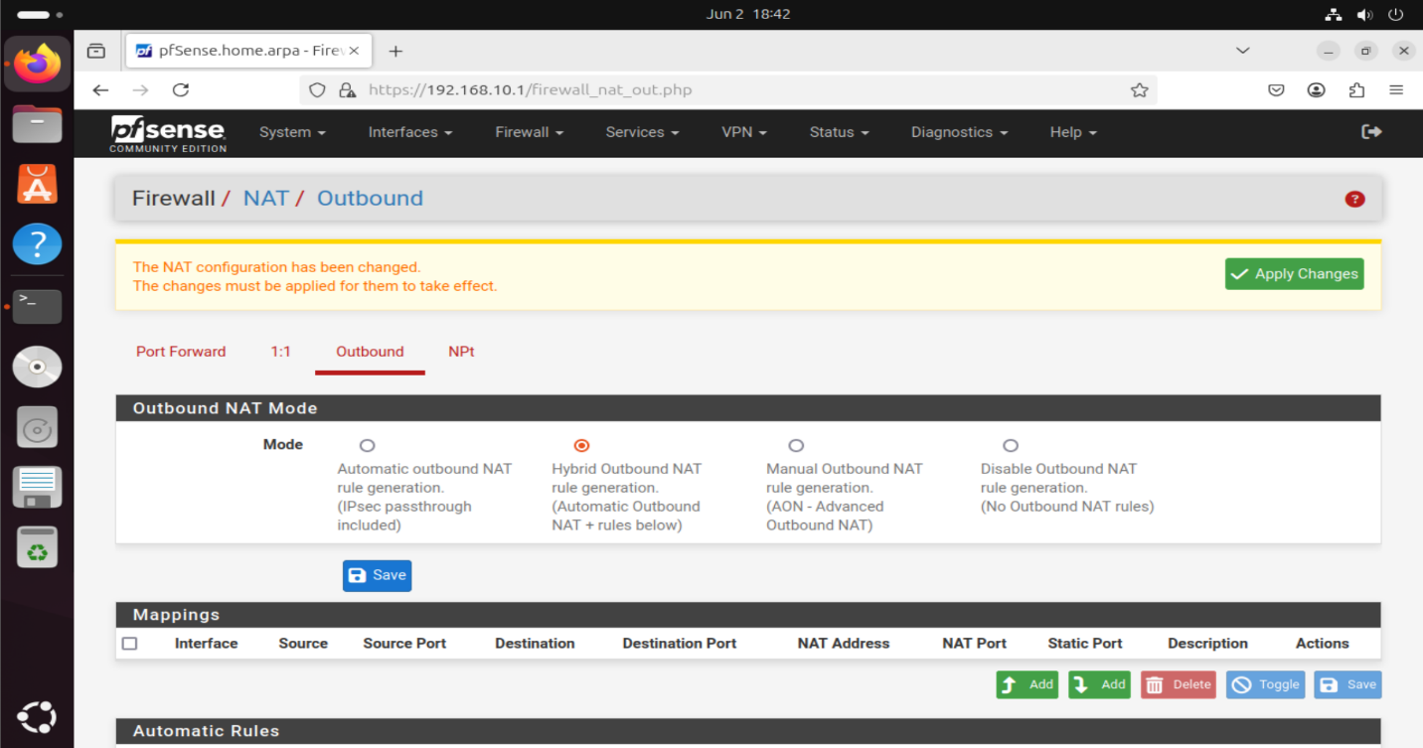Set the type from automatic to “Hybrid” and press “Save”.

Figure 3. : Selecting the Outbound NAT Mode as Hybrid

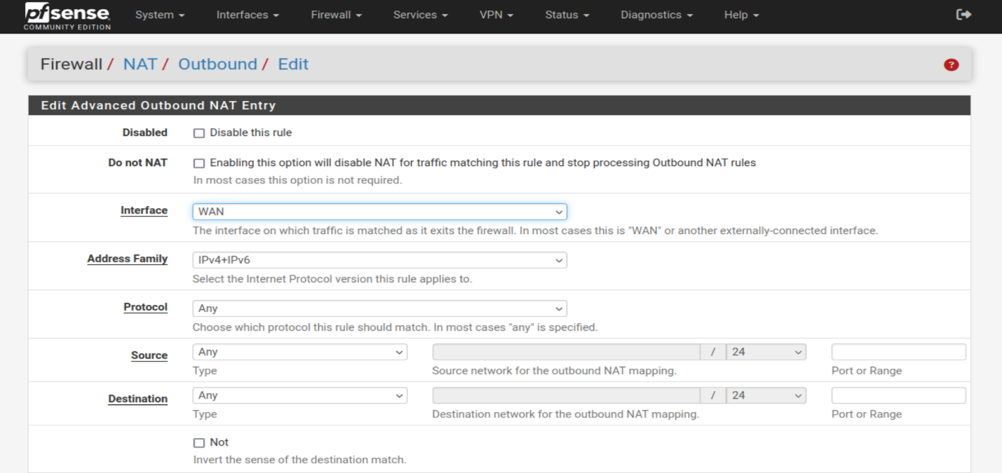Configure the rule as shown below: IPv4+IPv6, for Any Protocol, source address Any. Check Static Port in the Translation section of the page.

Figure 3. : Configuring the Outbound NAT Policy

Here, select the Source as WAN subnets and Destination as the LAN subnets.

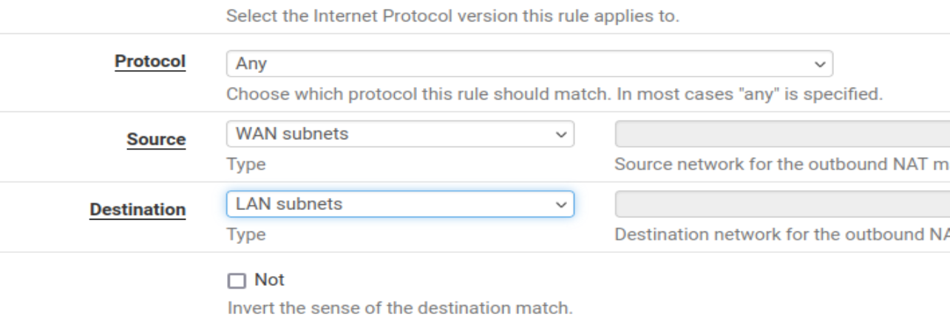

Figure 3. : Selecting the Protocol, Source and Destination

Click on Save and the changes will be applied successfully.

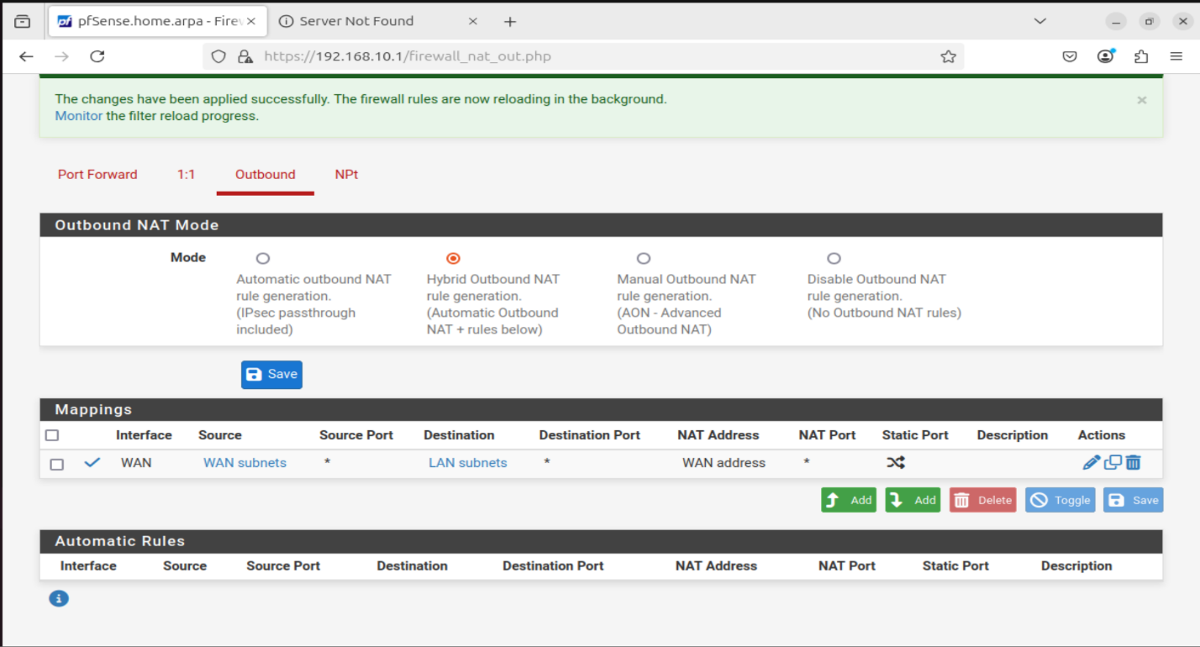

Figure 3. : Saving the Changes

### **3.5.2 LAN Rule**

The following screenshot shows the LAN interface firewall rule configured in pfSense. This rule allows internal systems (such as the Wazuh server and the vulnerable host) to communicate with external networks. It is essential for enabling traffic flow from the internal LAN segment to the WAN, including access to update repositories and SIEM log forwarding.

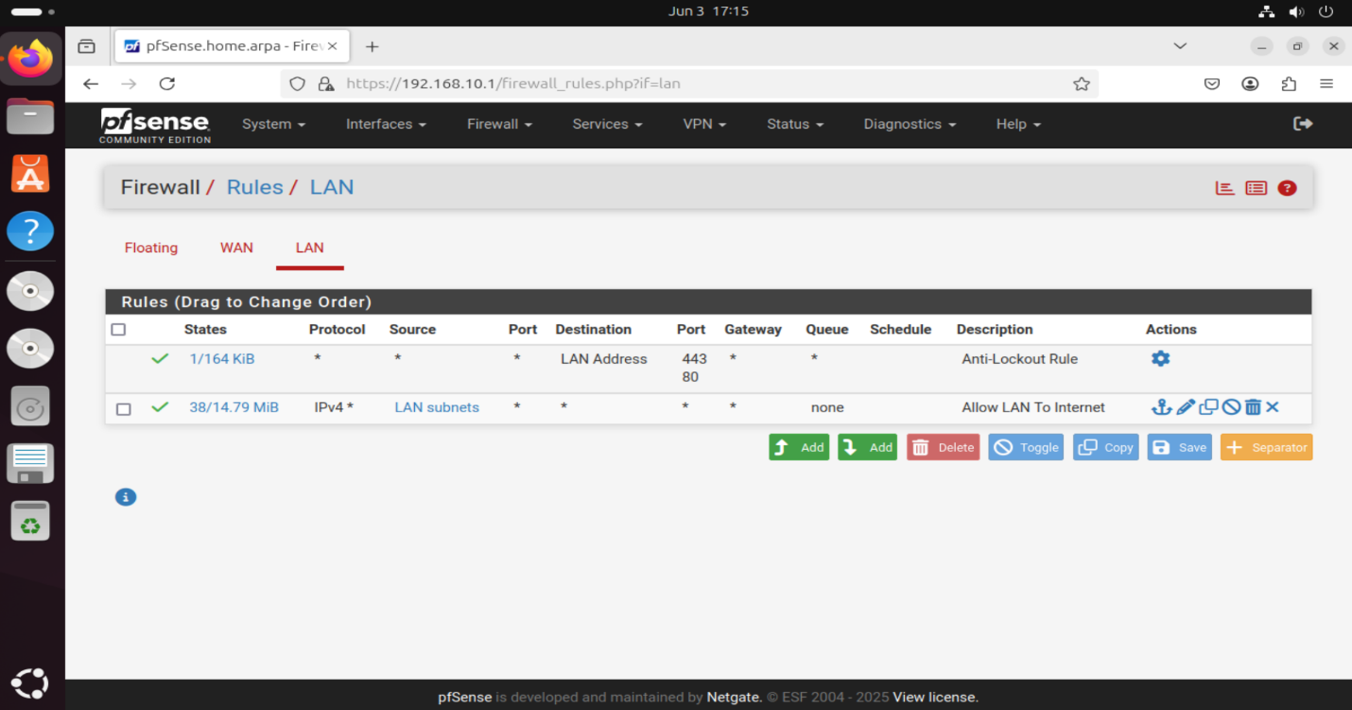

Figure 3. : LAN Rule

### **3.5.3 WAN Rule**

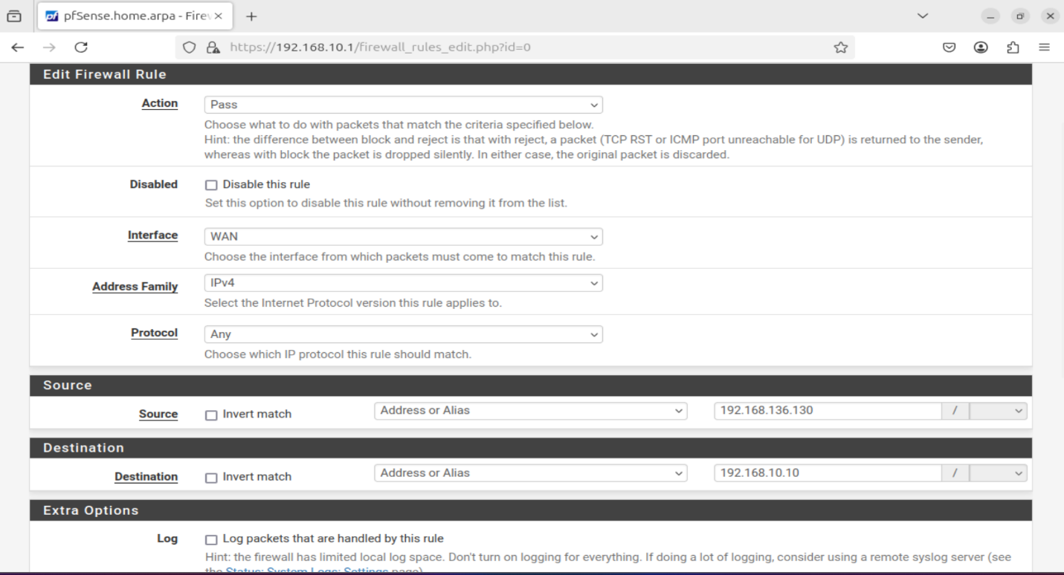The screenshot shows a pfSense WAN rule that blocks unauthorized access while allowing specific traffic from the Kali attacker machine for testing, preserving a controlled attack surface.

Figure 3. : Configuring WAN Rule

### **3.5.4 Suricata Installation and Configuration on pfSense**

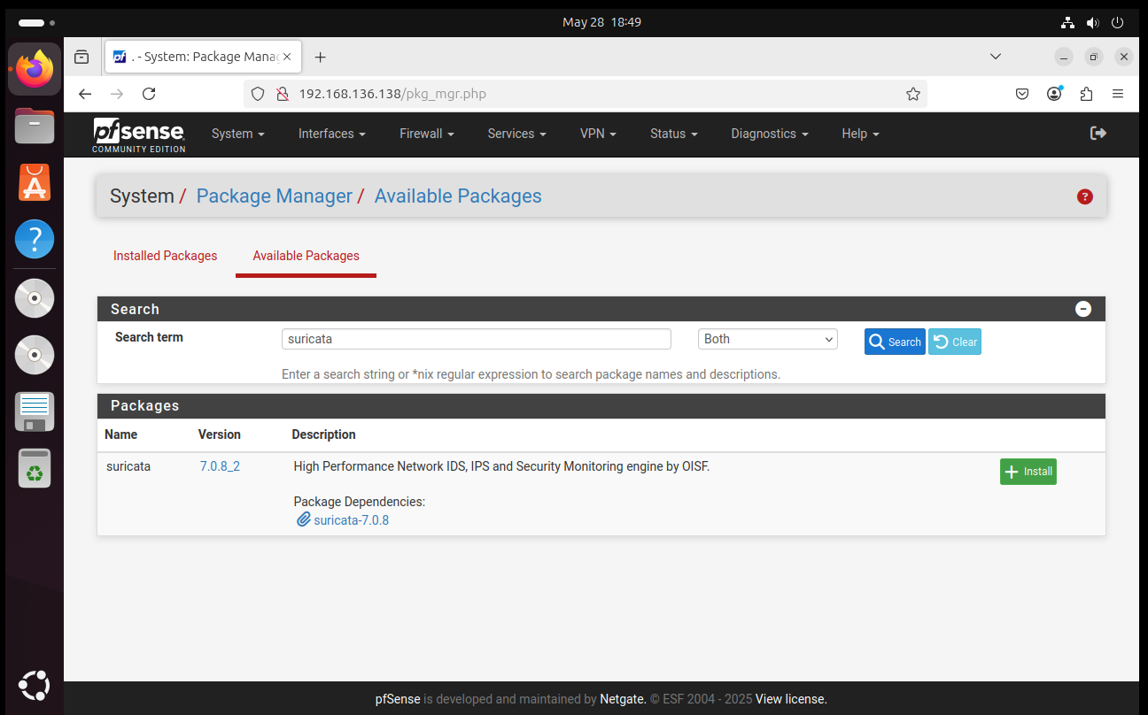To install Suricata, open the pfSense web interface and go to “System –> Package Manager –> Available “Packages”. The user should enter “Suricata” in the search bar.

Figure 3. : Accessing the Package Manager to Find Suricata

Click the Install button and wait for the installation process to complete.

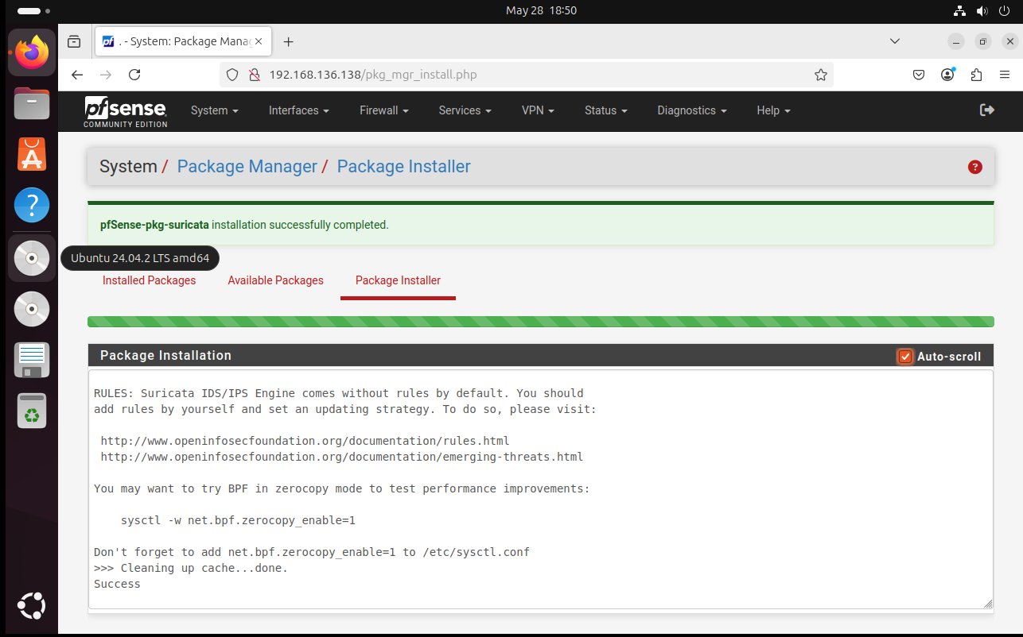

Figure 3. : Installing Suricata

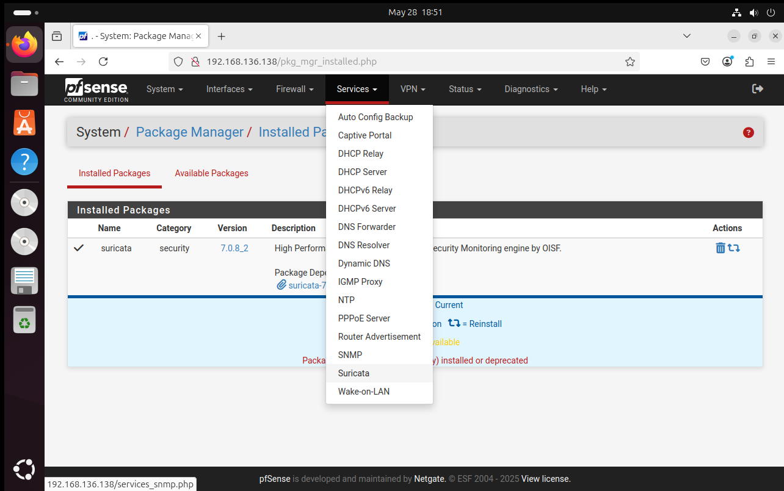To configure protection for specific interfaces, navigate to **Services > Suricata > Interfaces** in the pfSense web interface.

Figure 3. : Navigating Suricata in the Services Tab

After entering this section, click on **Add** to reveal several options. Within the **WAN Settings** area, select the specific WAN interface designated for service activation..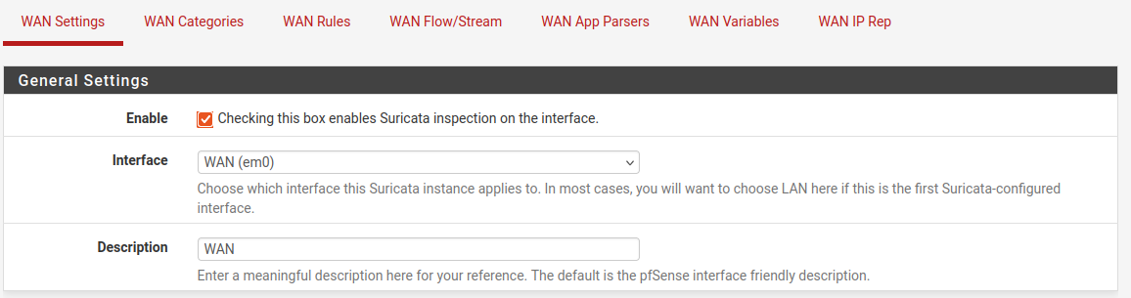

Figure 3. : Choosing the WAN Interface

In the logs part select Send Alerts to System Log to send the logs to the firewall and what level.

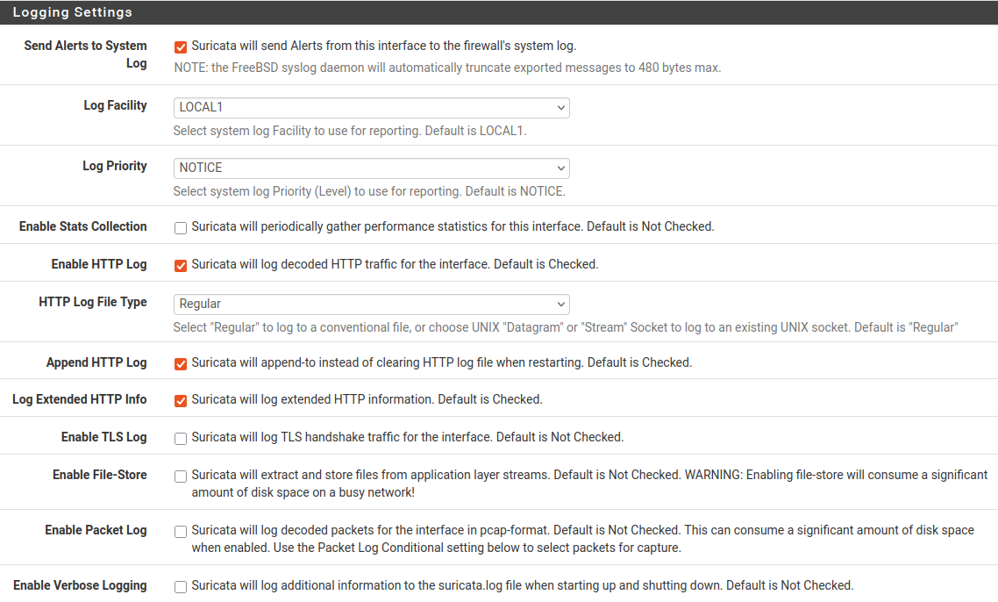

Figure 3. : Logging Settings

A very interesting option for the logs is the EVE Output Settings option saving them in json. Similarly, check the other option as required in the EVE Output Settings tab.

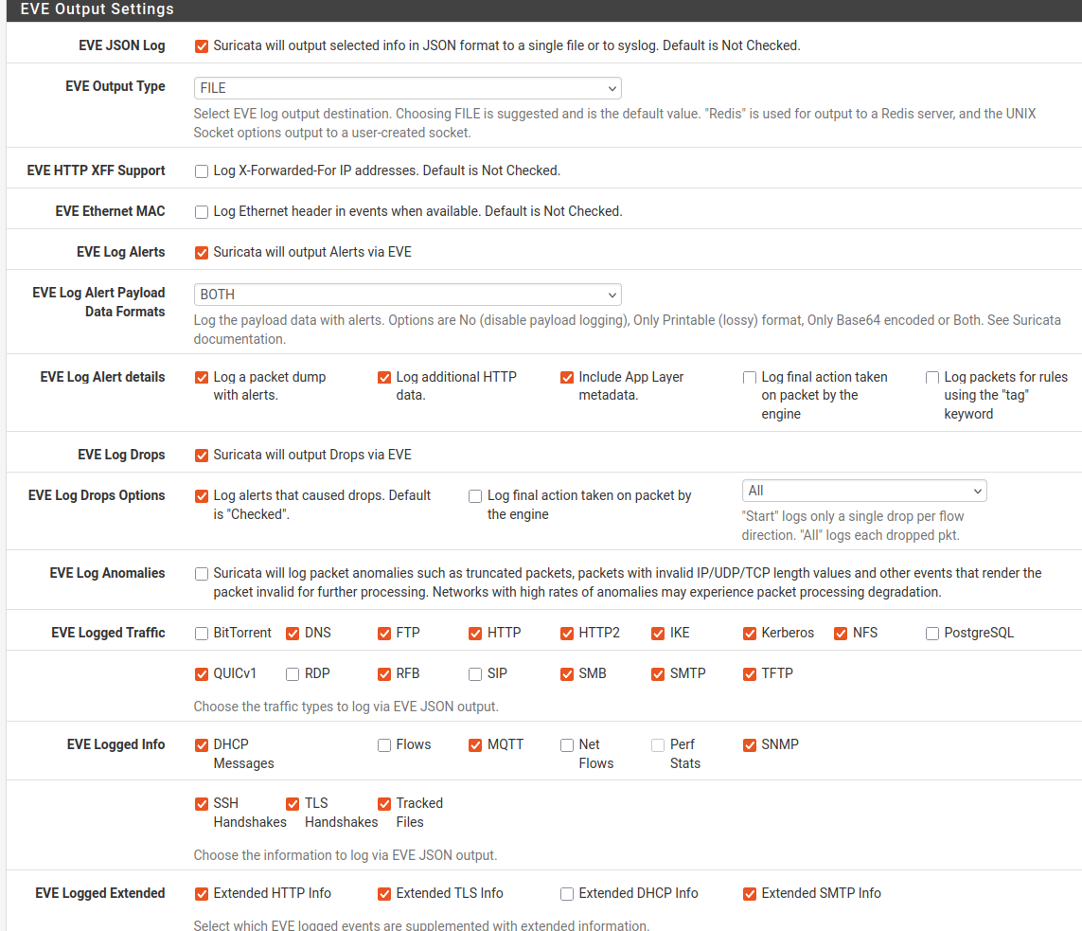

Figure 3. : Selecting the Required EVE Output Settings

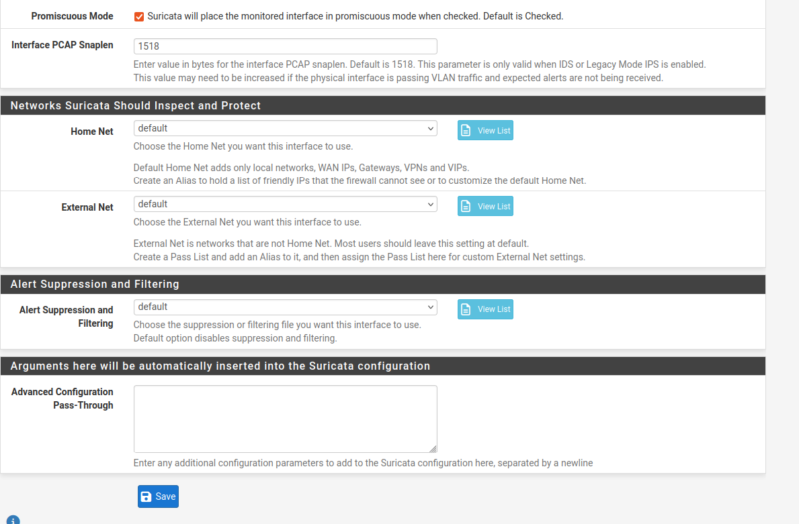Promiscuous mode is enabled to allow Suricata to inspect all network traffic on the selected interface, while all other settings remain configured with their default values..

Figure 3. : Enabling Promiscuous Mode

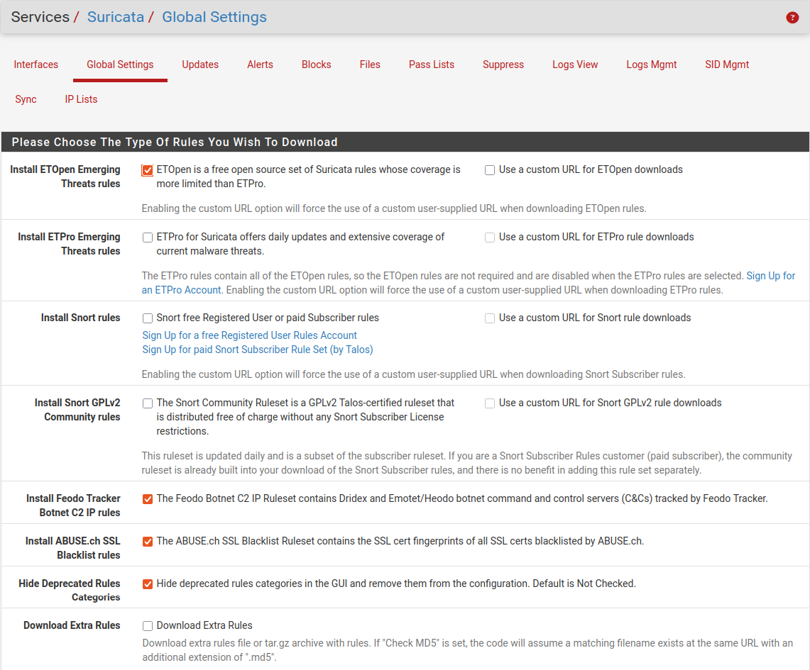In the **Global Settings** tab, the desired rule types are selected for download based on the detection needs and threat coverage requirements.

Figure 3. : Selecting the Rule Sets

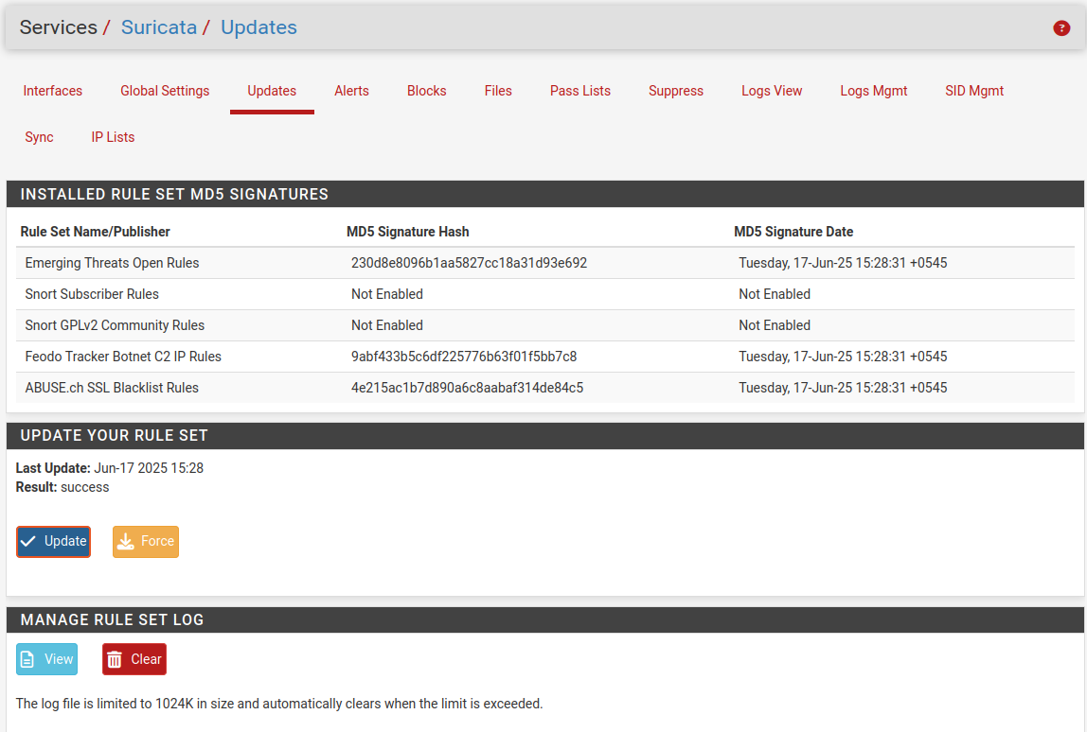After the rules are added, they can be manually downloaded by navigating to **Services > Suricata > Updates** and initiating the update process.

Figure 3. : Updating the Rule Set

After completing the configuration and saving the settings, Suricata is activated by navigating to **Services > Suricata > Interfaces** and clicking the **play icon** corresponding to the desired interface.

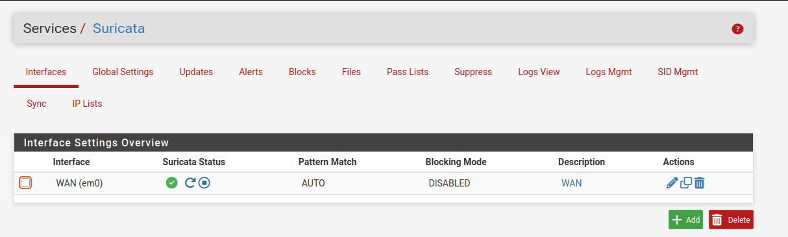

Figure 3. : Activating the Suricata

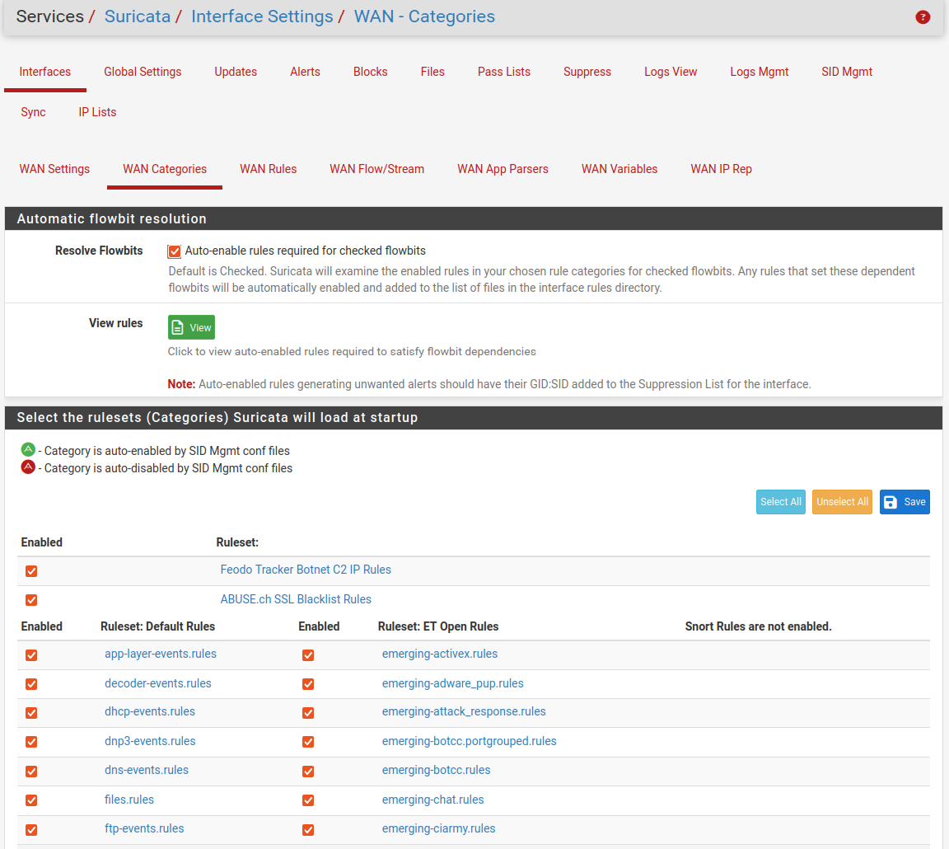Specific rule categories can be enabled by navigating to **Services > Suricata > Interfaces > WAN Categories**, where the available categories are listed for selection based on security requirements.

Figure 3. : Enabling the Required Rules

After saving the configuration, Suricata is enabled and restarted. The status of the Suricata service can then be verified to ensure it is running correctly.

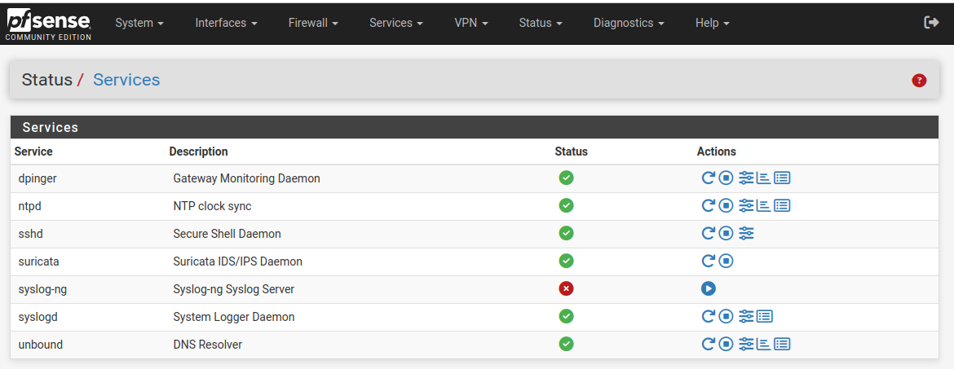

Figure 3. : Services

### **3.5.5 Snort Rules Installation and Configuration on pfSense**

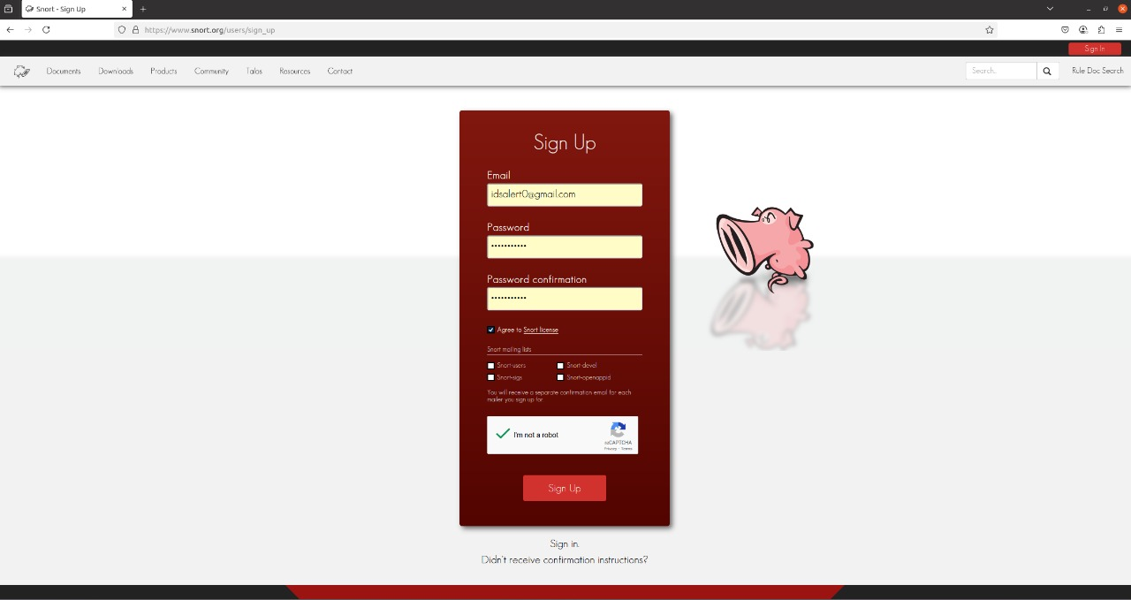Sign up for a free Snort.org account by entering the email address, choosing a password, and completing the CAPTCHA in order to download the Snort snapshot rules package.

Figure 3. : Snort Sign Up Page

Download the Snort Snapshot rules file. Suricata will not work properly with any Snort3 rules, so only use rules files designed for Snort 2.9.x versions with Suricata.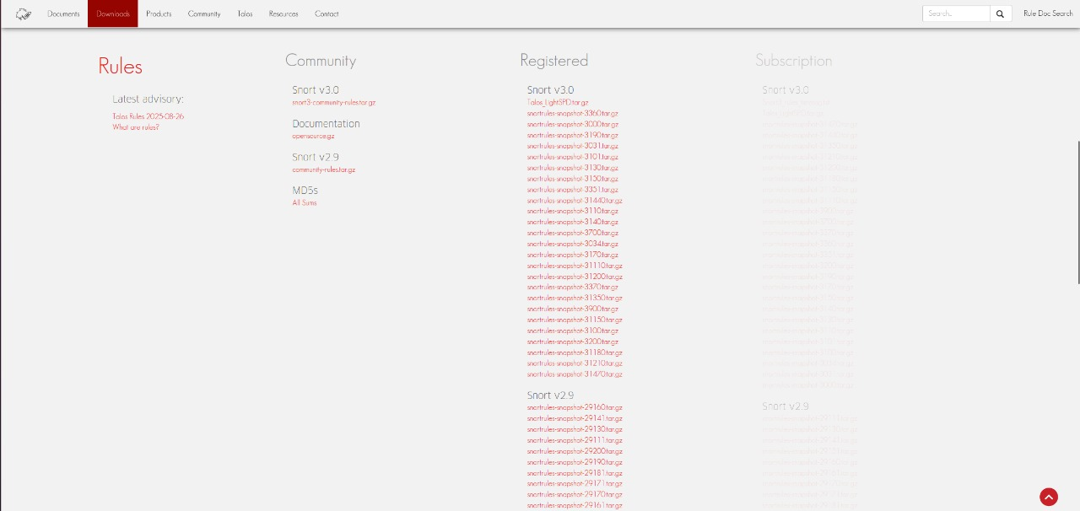

Figure 3. : Snort Snapshot Rules

After registering, access the Snort Oinkcode. This unique code is provided by Snort to registered users and is required for downloading the Snort VRT rule set.

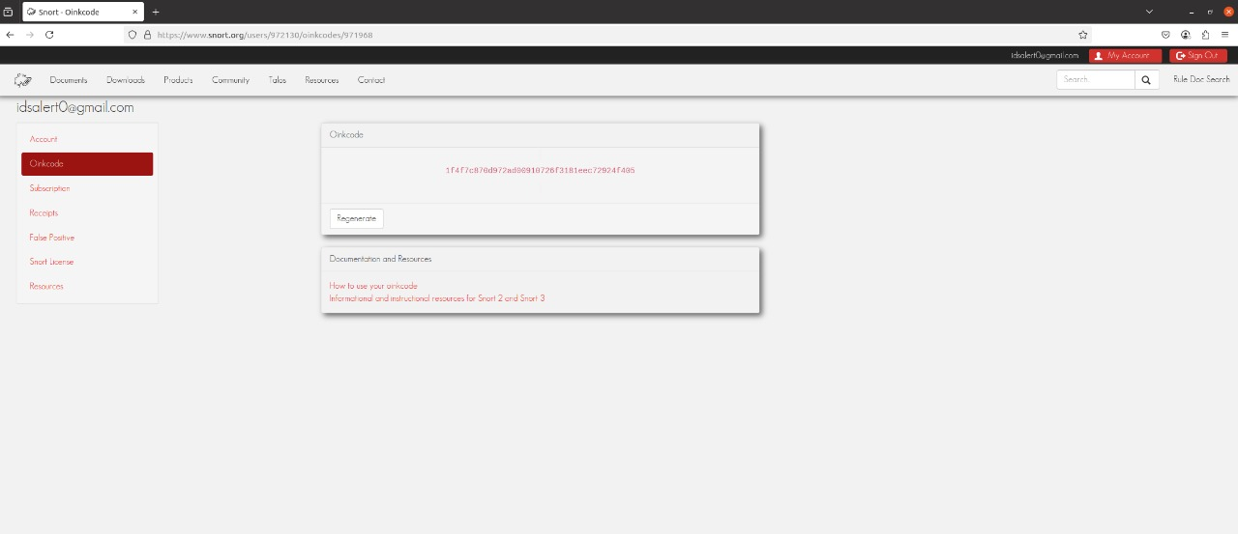The Oinkcode is essential for integrating updated rules into the Snort configuration on pfSense.

Figure 3. : Oinkcode

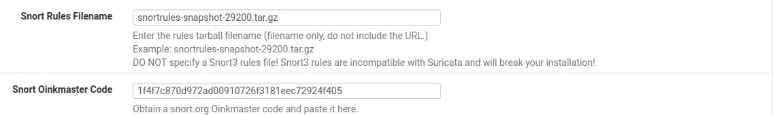Against “Snort Rules Filename”, enter the Snort release filename e.g. snortrules-snapshot-29120.tar.gz from <https://www.snort.org/downloads>. Copy the Oinkcode and Paste it

Figure 3. : Snort Rules Filename

## 3.6 Installation and Configuration of Wazuh Server in Ubuntu

At first, let us install Ubuntu. Select an appropriate ISO image in the process and install the Ubuntu.

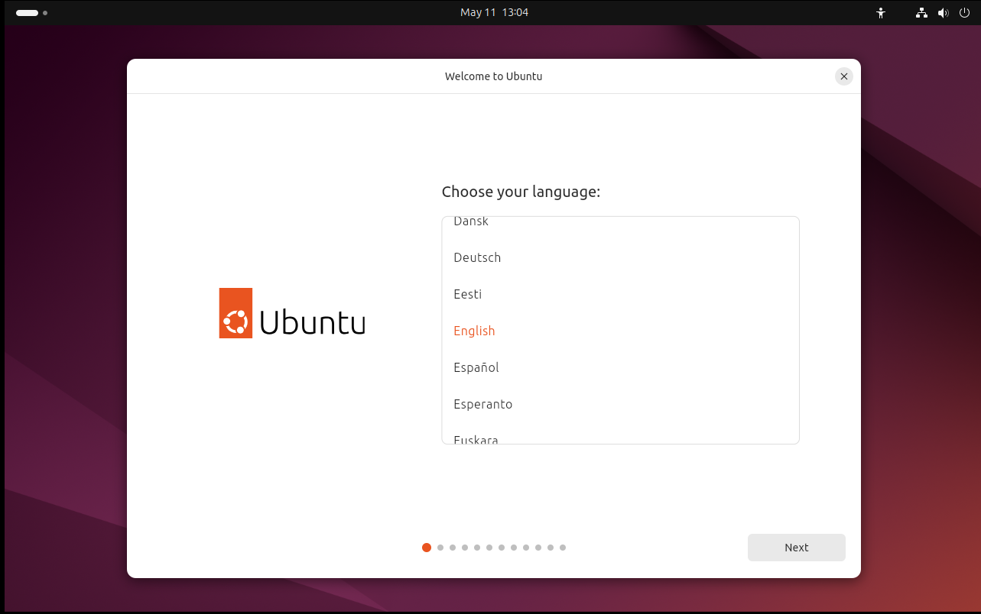After starting the VM, select a preferred language and then the installation of Ubuntu start.

Figure 3. : Selecting the Preferred Language

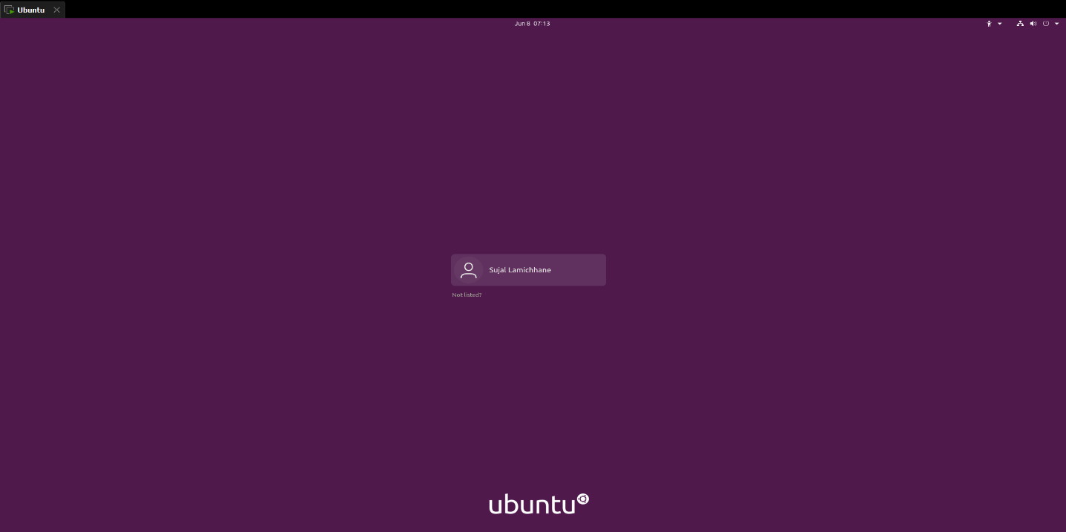Create the user account and follow the wizard. Wait until it finishes.

Figure 3. : Ubuntu OS Login Page

The first step is to upgrade the system.  
Once the system is upgraded, Download and execute the Wazuh installation assistant script with the following commands. This script simplifies the installation process, guiding through the setup of Wazuh effortlessly.

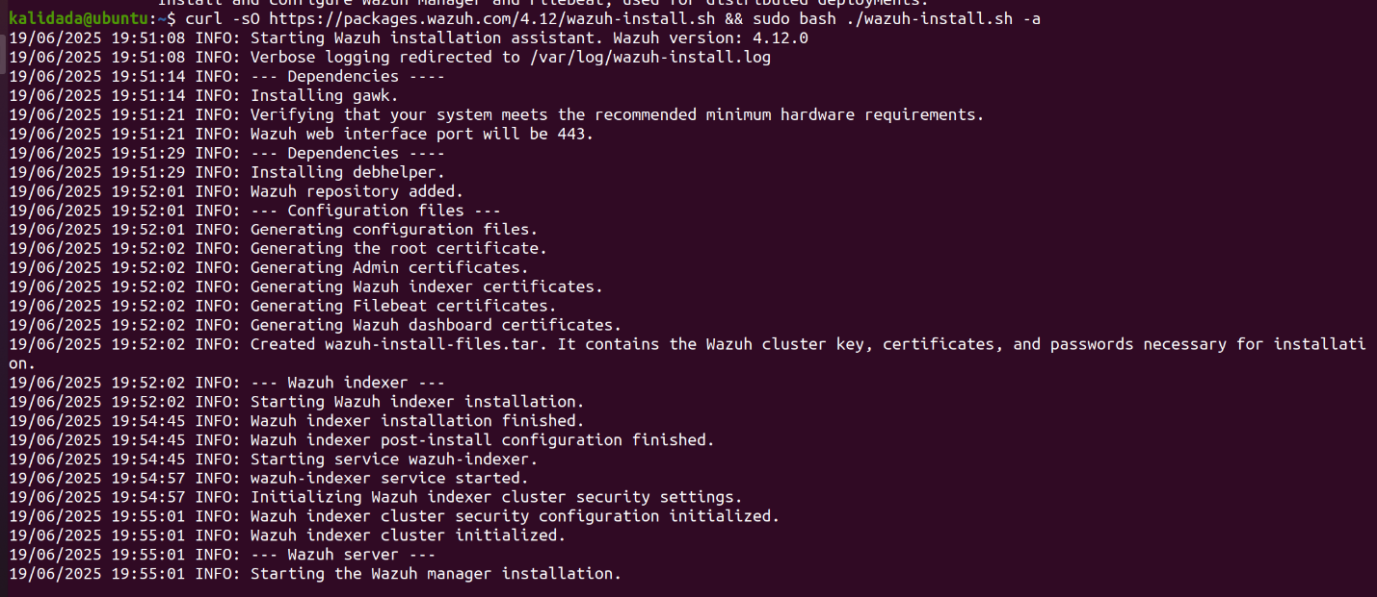

Figure 3. : Installing packages

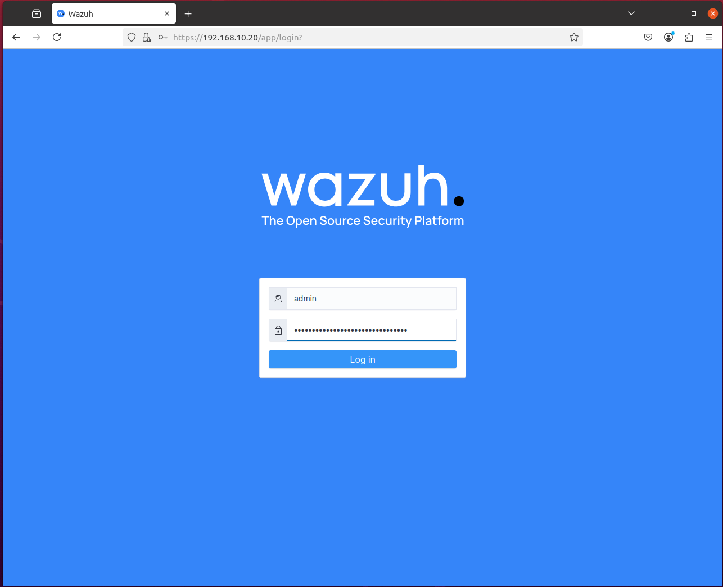With this, Wazuh server is ready. Copy the provided credentials from the terminal, enter the server IP into the browser, and proceed to login. Navigate to https://192.168.10.20 in the web browser, log in using the provided credentials.

Figure 3. : Wazuh Server Login Page

Once the login is successful, Wazuh SIEM dashboard can be explored.

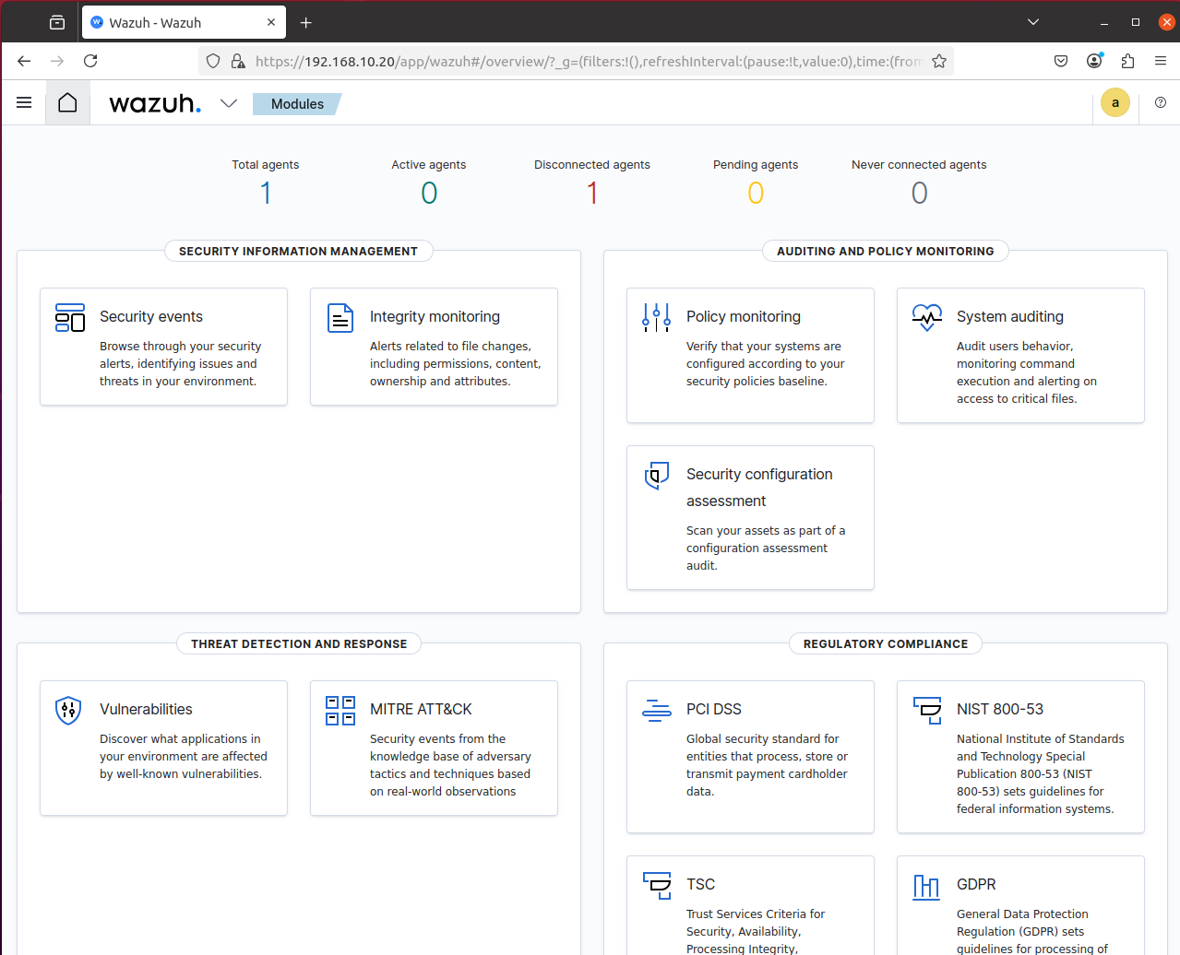

Figure 3. : Wazuh Dashboard

### **3.6.1 VirusTotal Integration**

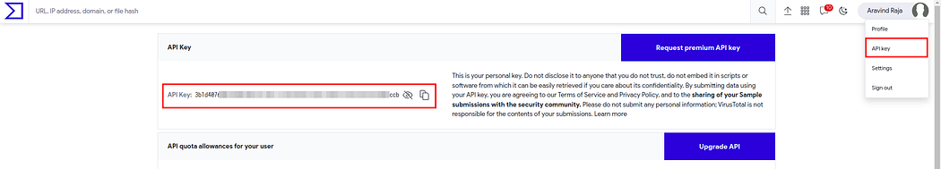Create an account in the Virustotal and navigate to profile > API Key and copy the API key.

Figure 3. : VirusTotal API Key

Edit the /var/ossec/etc/ossec.conf in Wazuh server with the following snippet.

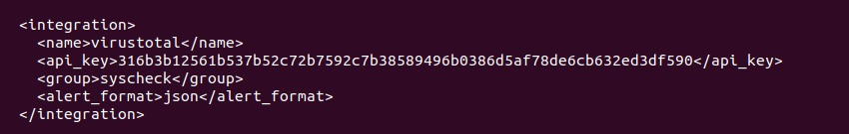Add your Virustotal API key within the field <api_key></api_key> and save the file.

Figure 3. : Integration

After applying the configuration, restart the Wazuh manager.

Add the following snippet in the /var/ossec/etc/ossec.conf in Wazuh agent.

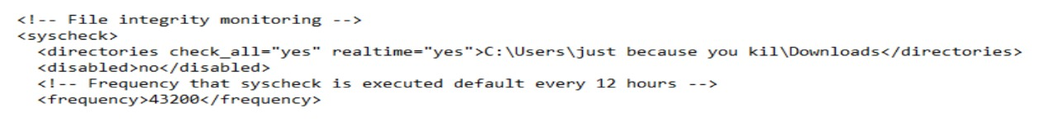The directory \users\just because you kil\Downloads was added for real-time monitoring in the agent.

Figure 3. : File Integrity Monitoring setup

Restart the wazuh agent to apply the changes

Using the wget or Curl functionalities download the malicious file in the agent machine in the directory \users\just because you kil\Downloads mentioned in the configuration.

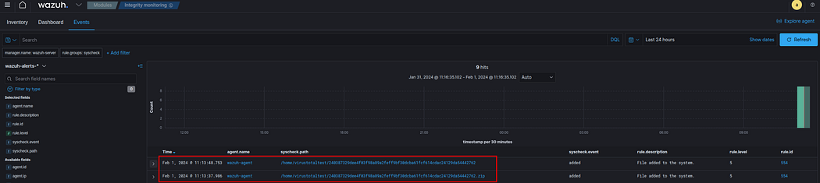Navigate to the Wazuh dashboard Modules > Integrity monitoring and we can see the zip file added and also the extracted one with in the directory.

Figure 3. : Wazuh Integrity Monitoring

The file added was cross checked with the Virustotal database for any malicious entries

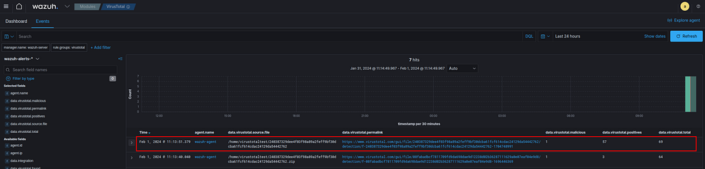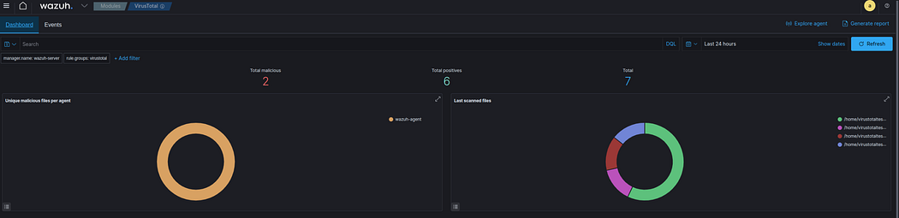We can see the files detected in the directory mentioned in the agent’s configuration file.

Figure 3. : Detected file shown in Wazuh Dashboard

Figure 3. : Files Detected in the Directory

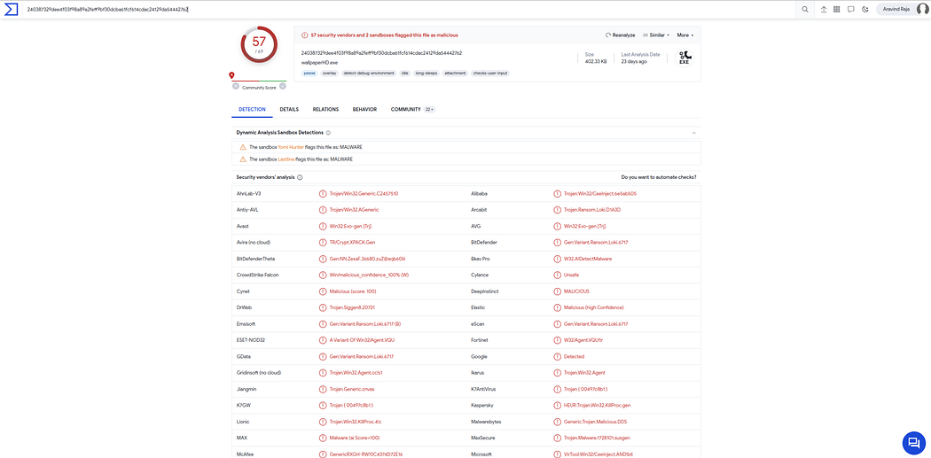

Figure 3. : VirusTotal Detection

The above activity is only for the detection and not removing or active-response for the malicious actions.

## 3.7 Installing Wazuh Agent in pfSense

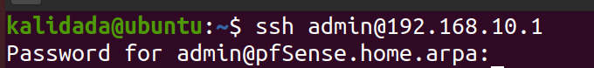SSH connection from the Ubuntu system is established to the pfSense firewall using its LAN IP address 192.168.10.1. This access is required to perform command-line operations for installing the Wazuh agent directly on pfSense.

Figure 3. : SSH connection to pfSense

Successful login will provide the following interface, among them option 8 is choosen to access the pfSense Shell.

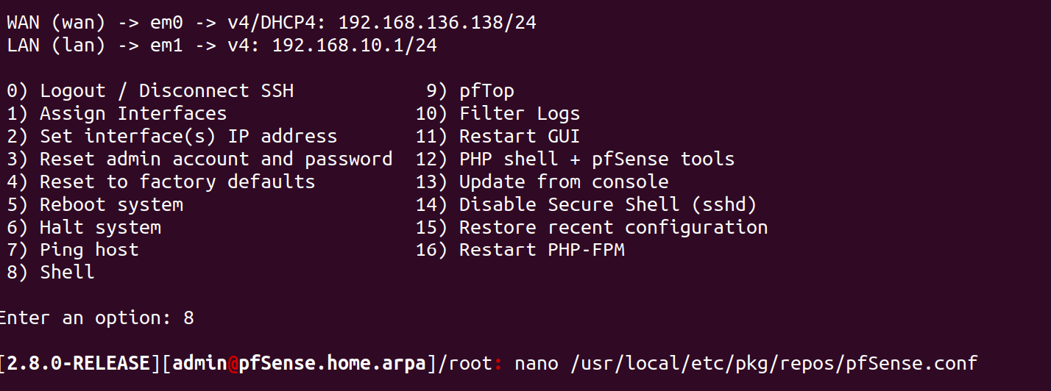To enable package installation on pfSense, the repository configuration file located at /usr/local/etc/pkg/repos/pfSense.conf needs to be modified. The following screenshot shows the command used to open the file using nano.

Figure 3. : Editing the pfSense.conf File

Edit the file /usr/local/etc/pkg/repos/pfSense.conf;

and change the line;

FreeBSD: { enabled: **no** }

to;

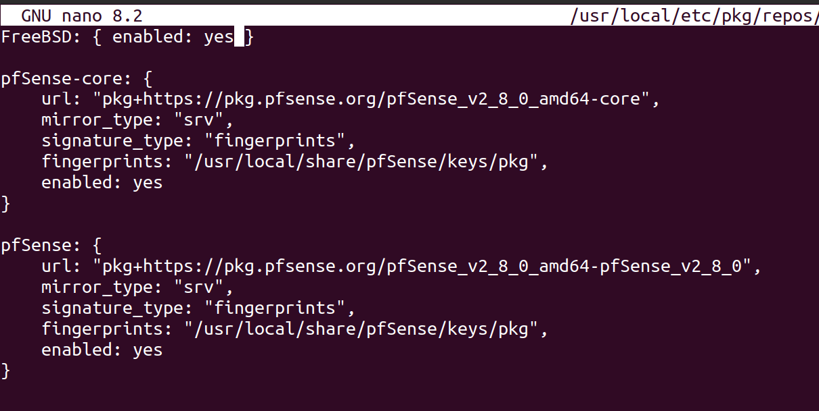FreeBSD: { enabled: **yes** }

Figure 3. : Enabling the FreeBSD

Once the FreeBSD repositories has been enabled, run the command below to updates package repository catalogues;

**pkg update**

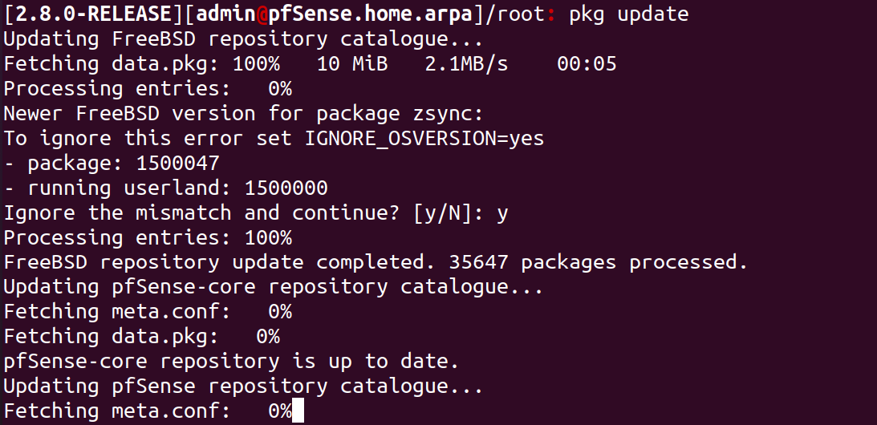

Figure 3. : Updating the Package Repository

Wazuh 4.12.0 is the [current stable release version](https://documentation.wazuh.com/current/release-notes/index.html). Thus run the command below to check what version is provided by the official FreeBSD repositories;

Figure 3. : Checking the Wazuh-Agent Version

Edit the Wazuh agent config file and set the Wazuh manager IP;

nano /var/ossec/etc/ossec.conf

Change the section;

<server>

<address>**IP**</address>

</server>

to;

<server>

<address>**192.168.10.20**</address>

</server>

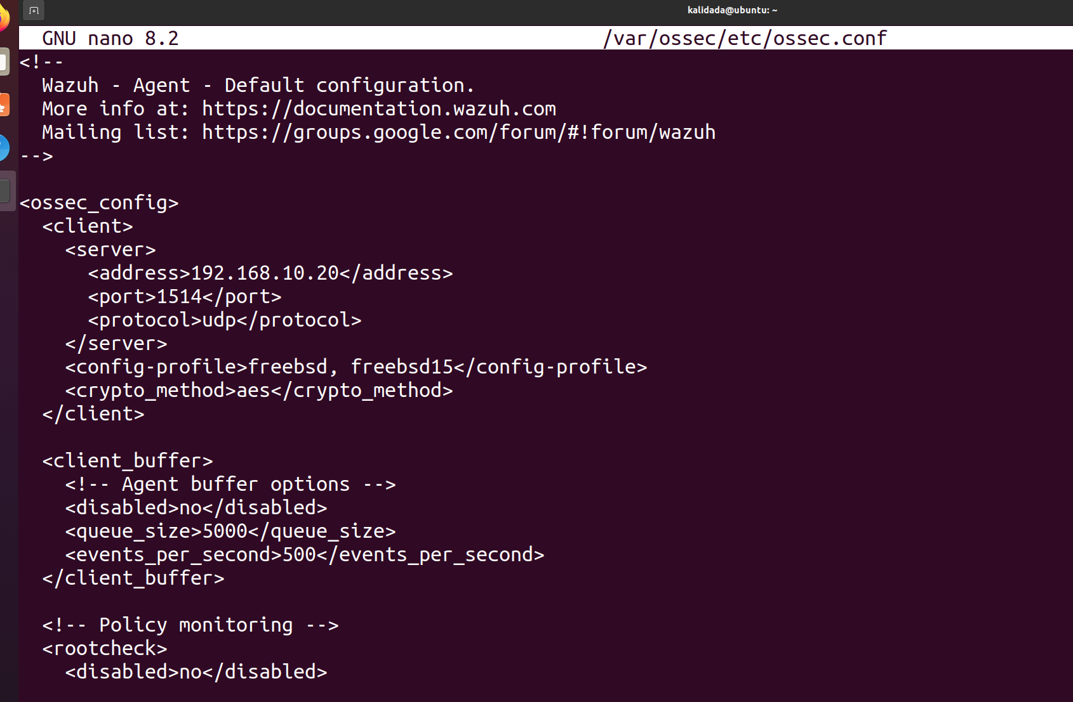Enable and start Wazuh agent by using the command as shown in the screenshot below;

Figure 3. : Editing and Setting Wazuh Manager IP



Figure 3. : Enabling and Starting Wazuh Agent

The use of FreeBSD official repositories on pfSense can now be disabled.



Figure 3. : Opening pfSense.conf File using Nano



Figure 3. : Opening FreeBSD.conf File using Nano

Change the line;

FreeBSD: {enabled: **yes**}to; FreeBSD: {enabled: **no**}

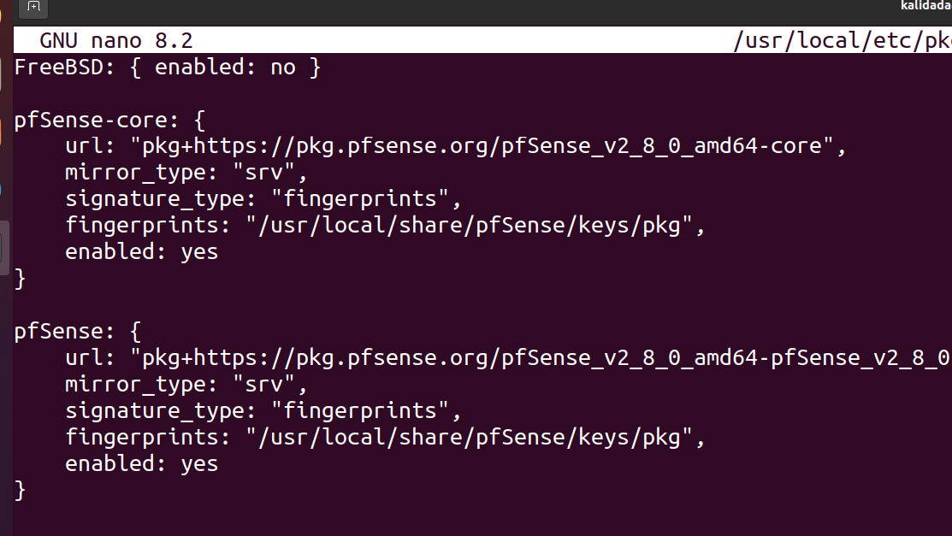Update package catalogue;

Figure 3. : Disabling FreeBSD Official Repositories

pkg clean all

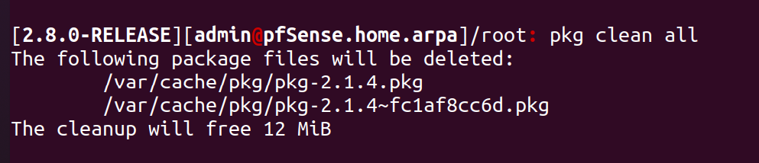pkg update

Figure 3. : Cleaning Package Catalog

### **3.7.1 Confirm pfSense Wazuh Agent Status on Wazuh Manager**

Login to Wazuh manager interface and confirm the pfSense agent status;

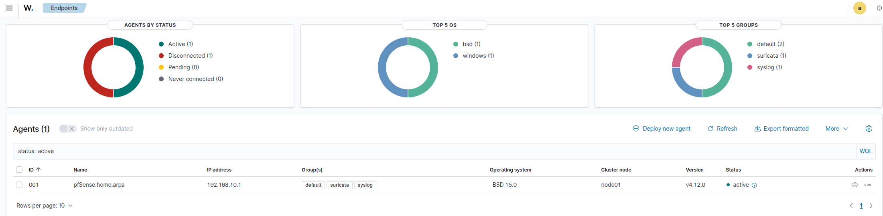

Figure 3. : Confirming Wazuh Agent Status in Manager

pfSense Wazuh agent (pfSense.home.arpa) is connected to the Wazuh server and is up and running.

## 3.8 Installing Wazuh Agent in Windows (Vulnerable System)

The Wazuh agent monitors Windows systems and communicates with the Wazuh server in near real-time through an encrypted and authenticated channel.

Download the Wazuh agent Windows installer and save the installer on the Windows endpoint.

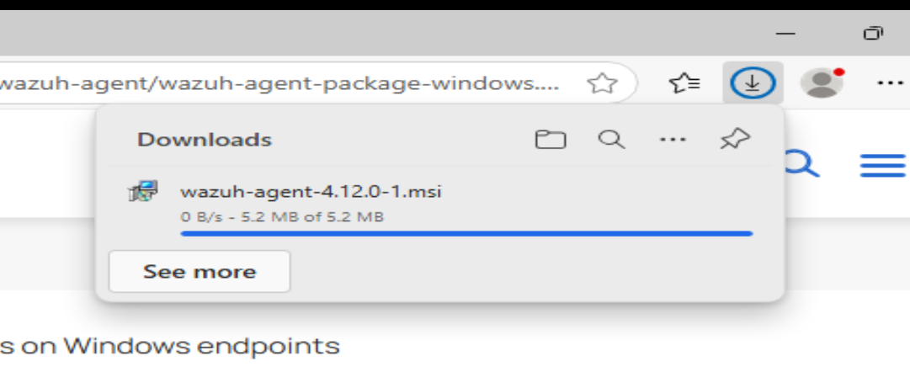

Figure 3. : Downloading Wazuh Agent

Wazuh agent installation can be performed using either the Command Line Interface (CLI) or Graphical User Interface (GUI). Open the powershell as a Administrator and execute the command.

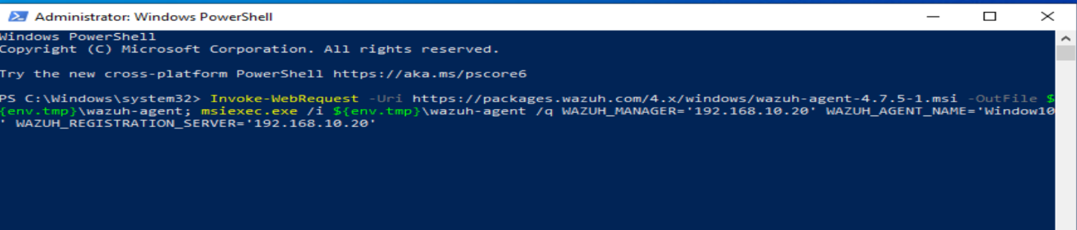

Figure 3. : Executing the Command to Install the Package

After installation, the Wazuh agent service must be started to begin monitoring.

Open CMD or PowerShell and run:

NET START Wazuh

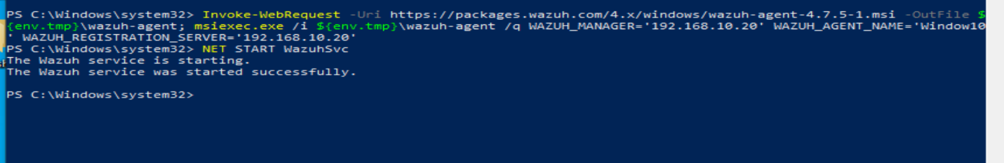

Figure 3. : Starting the Wazuh Agent Service

The Wazuh agent is now successfully installed and configured on the Windows endpoint. It communicates securely with the Wazuh server, sending critical monitoring data.

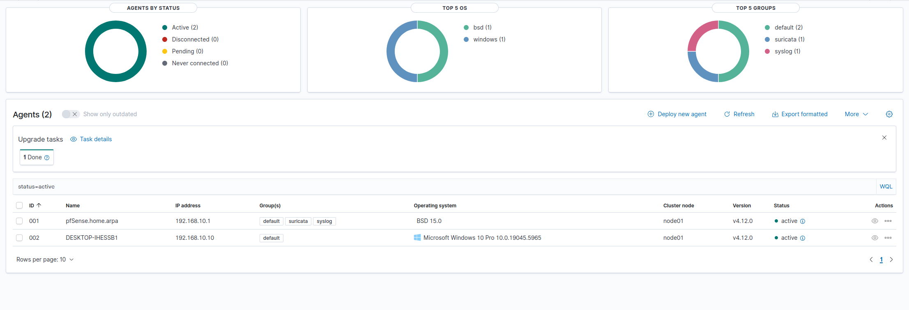

Figure 3. : Agent Successfully Connected to the Manager

## 3.9 Alerting and Notification

After the configuration is completed and Suricata is actively monitoring traffic, generated alerts are forwarded and become visible in the **Wazuh dashboard** for centralized monitoring and analysis.

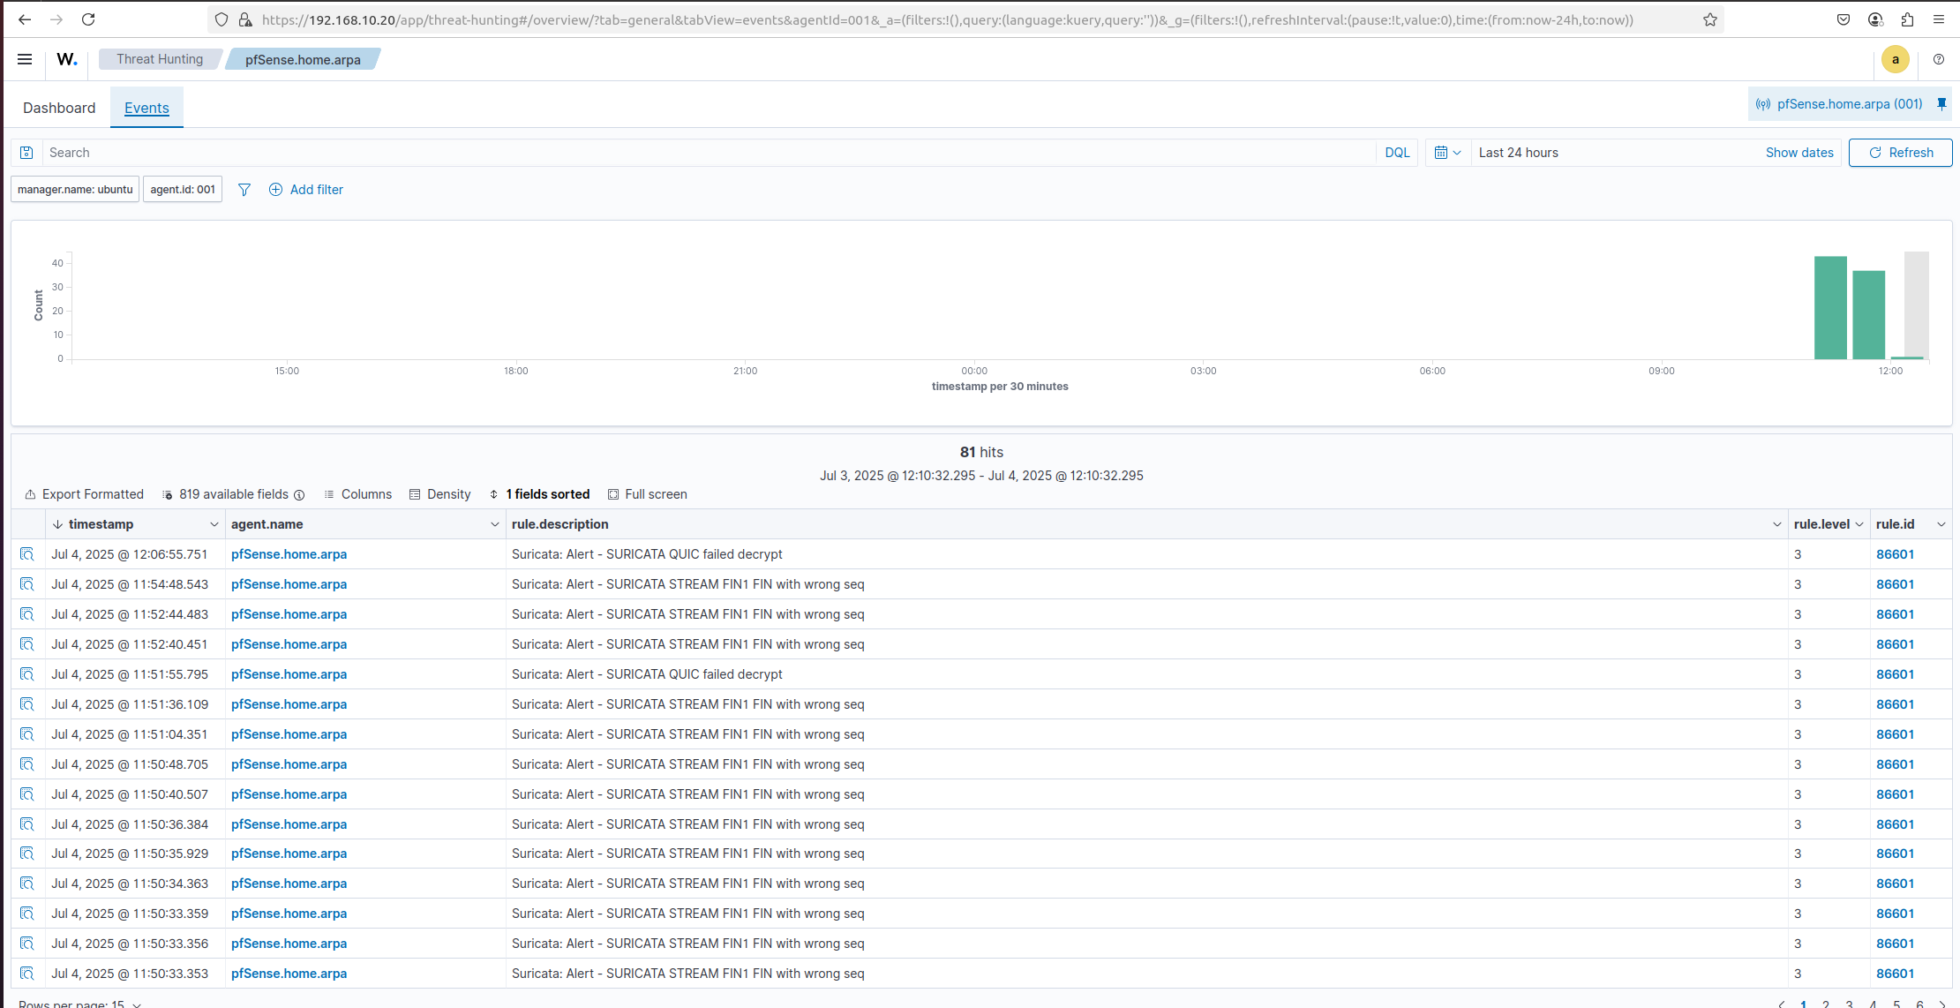

Figure 3. : Suricata alerts in Wazuh Dashboard

The system is configured to send emails from the command line using **Postfix** and **Mailutils**, with the required authentication libraries and trusted certificate authorities installed. This setup facilitates automated email delivery for purposes such as system alerts, backup notifications, and log reporting.

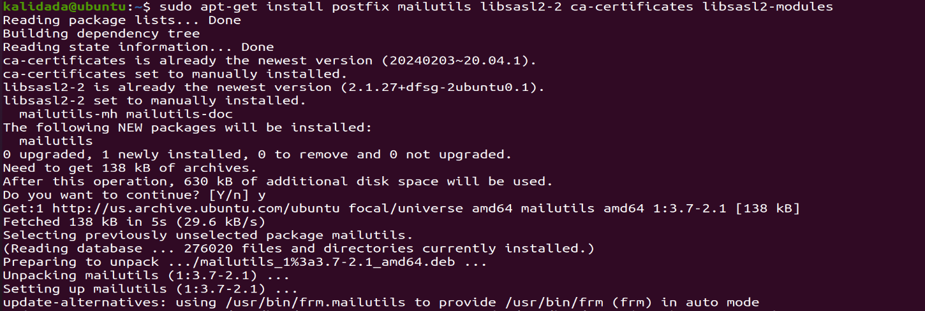

Figure 3. : Installing Postfix and Mailutils Packages

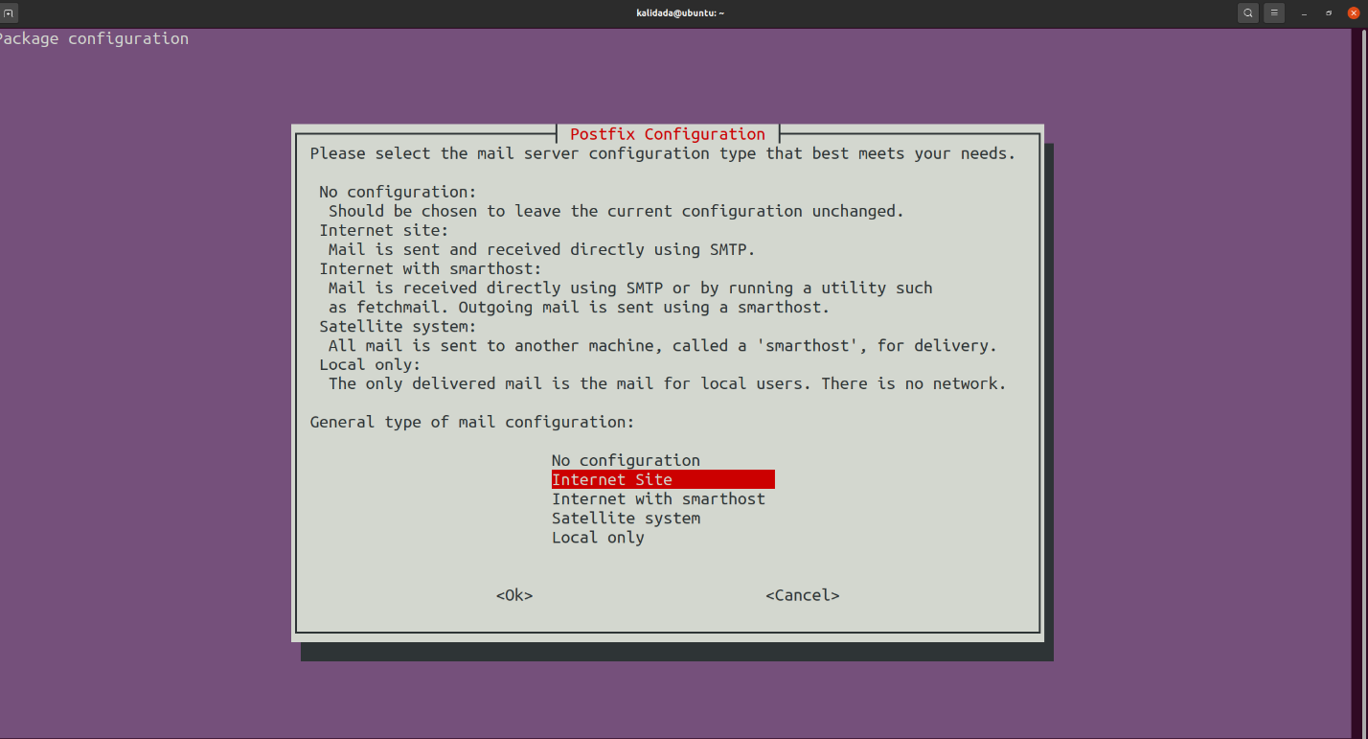During the installation of the package, a configuration prompt appears asking for the **"general type of mail configuration."** In this window, the **"Internet Site"** option is selected, followed by confirming the selection by clicking the **OK** button.

Figure 3. : Selecting Internet Site

The /etc/postfix/main.cf file is related to the settings needed for Postfix to use the external SMTP server. The settings instruct Postfix to deliver emails via a relay host, which is an external SMTP server.

Figure 3. : Opening main.cf File Using Nano

Add the following lines to the end of the file:

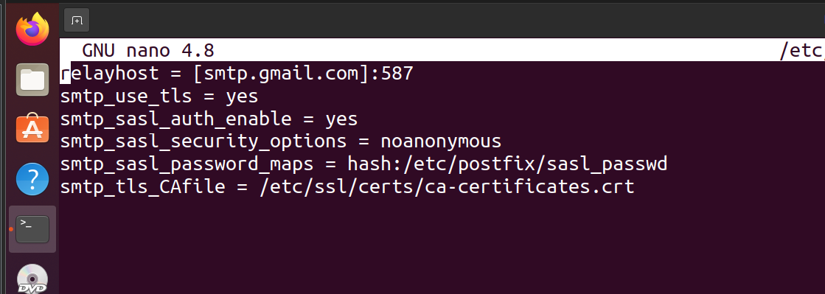

Figure 3. : Editing main.cf File

The /etc/postfix/sasl_passwd file contains the usernames and passwords for the external SMTP server. Open the /etc/postfix/sasl_passwd file and From the Google account create and insert the username and password generated by Google. And paste it in sasl/password as soon in figure:

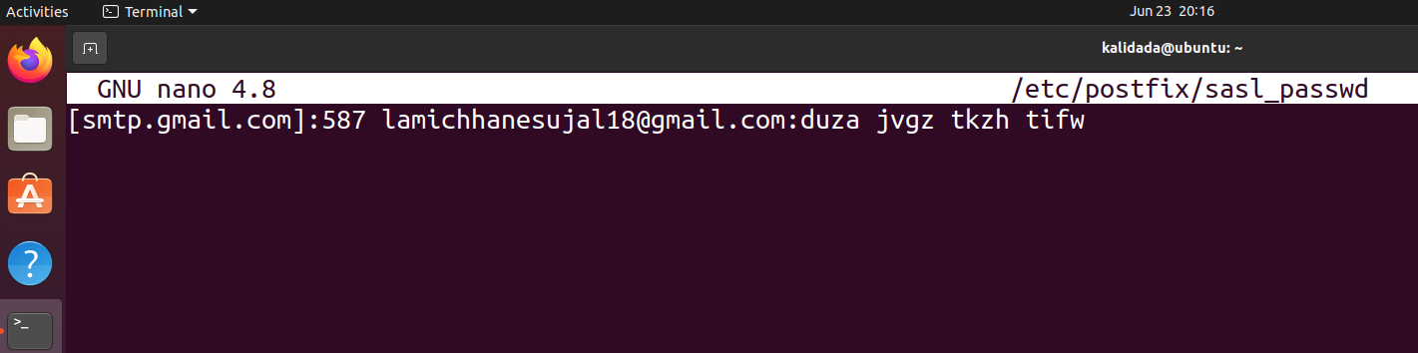

Figure 3. : Setting the Email and Password

Create a Hash database sasl_passwd.db file in the /etc/postfix/ directory using the **postmap** command. This file is used for querying Postfix lookup tables.

Run the following command:

sudo postmap /etc/postfix/sasl_passwd

Set up the hostname parameter and relay server in the */etc/postfix/main.cf* configuration file. Run:

sudo nano /etc/postfix/main.cfCopy

Find the myhostname parameter and ensure it is the FQDN that is configured in the wizard after the installation.

Secure the email password by using this command (sudo chmod 600 /etc/postfix/sasl_passwd)to ensure only the root user can access them.

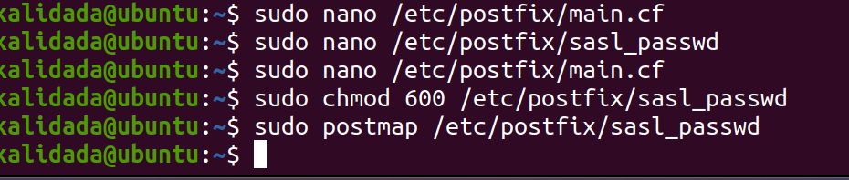

Figure 3. : Securing the Email Password

Complete the configuration by restarting the Postfix service to make sure the changes take effect. Run:

sudo systemctl restart postfix

### **3.9.1 Testing SMTP Server**

Test the SMTP server by sending an email.

Send an email by piping the echo command output to the **mail** command.

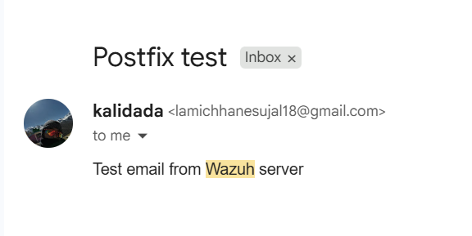After sending the email, verify that it was sent by checking the mail.

Figure 3. : Test email from wazuh server

To enable email alerting in Wazuh (OSSEC), the configuration file located at /var/ossec/etc/ossec.conf is modified. The <global> and <alerts> sections are edited to define the SMTP server, recipient address, sender address, and alert level. This ensures that when a monitored event meets the defined threshold, an alert email is automatically triggered and sent.

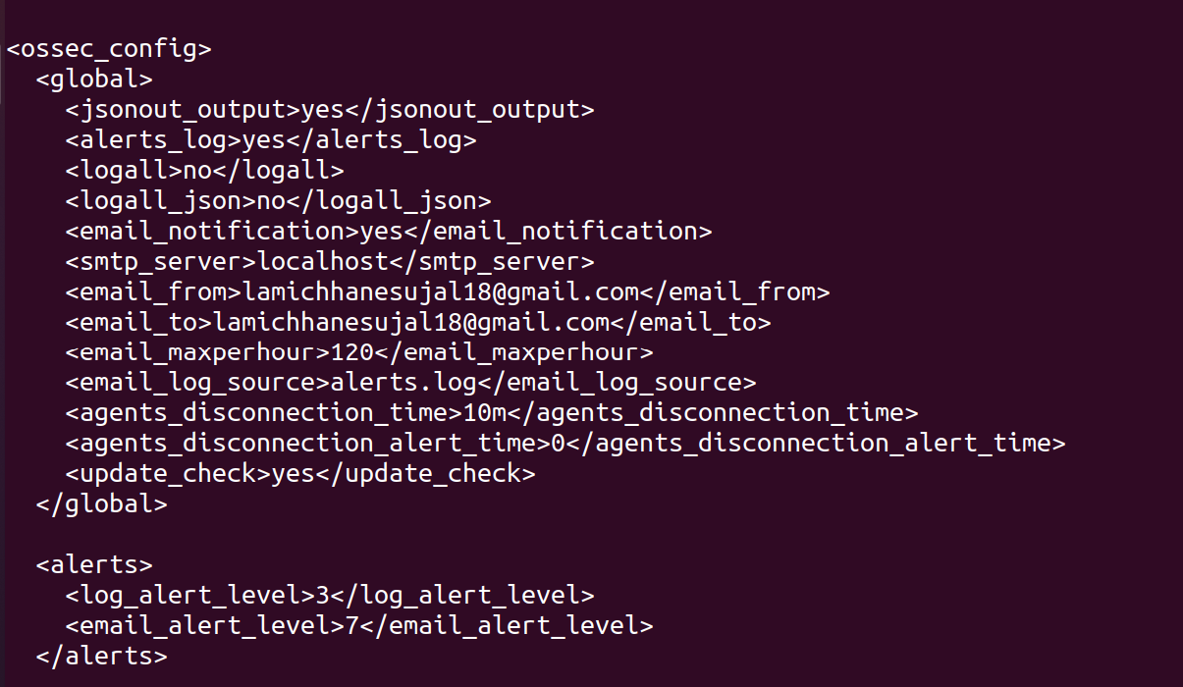

Figure 3. : Configuring ossec.conf file

Sample alert to admin from wazuh.

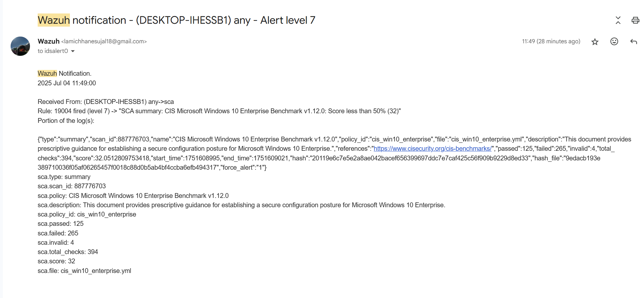

Figure 3. : Sample Alert

# CHAPTER 4: EPILOUGE

## 4.1 Outcome

The outcome of this project is the successful deployment of a multi-layer SIEM-based Intrusion Detection System that integrates pfSense, Suricata, Wazuh, and VirusTotal to deliver comprehensive security monitoring and threat detection. The system simulates real-world cyberattacks, enabling the identification of both network-level intrusions and host-based malicious activities in real time. It demonstrates the capability to detect intrusion attempts, correlate logs from multiple layers, and enhance malware detection through VirusTotal’s threat intelligence verification. Actionable alerts are generated via the centralized Wazuh dashboard, ensuring rapid awareness and response by the administrator. This project highlights how integrating layered security with external threat intelligence improves visibility, strengthens incident response, and enhances the overall cybersecurity posture of the internal network.

## 4.2 Time Schedule

|  |  |  |  |
| --- | --- | --- | --- |
| Date | Days | Key Tasks | Status |
| 26 May – 1 June | 7 | Preliminary Research | Completed |
| 2 June – 8 June | 7 | Infrastructure Preparation | Completed |
| 9 June – 18 June | 10 | Tool Installation & Configuration | Completed |
| 19 June – 27 June | 9 | System Integration | Completed |
| 28 June – 5 July | 8 | Issue Resolution | Completed |
| 6 July – 12 July | 7 | Testing & Verification | Completed |
| 13 July – 19 July | 7 | Final Reporting & Documentation | Completed |
| 20 July | 1 | Buffer & Submission | Completed |

Table 4. 1: Time Schedule

## 4.3 Budget Analysis

|  |  |
| --- | --- |
| **Item** | **Estimated Cost (USD)** |
| Hardware (Servers/VM Hosts) | $1500 |
| pfSense Hardware/VM Setup | $300 |
| Suricata Setup | $0 |
| Wazuh Server & Agents | $0 |
| Networking Equipment | $600 |
| Storage (Logs/Backups) | $400 |
| Miscellaneous | $300 |
| Total | $3100 |

Table 4. 2: Budget Analysis

1 United States Dollar = 140.92 NPR

# CHAPTER 5: CONCLUSION

This project implements a robust intrusion detection and security monitoring system using pfSense, Suricata, and Wazuh SIEM, designed for a controlled lab environment to effectively counter modern cyber threats. The system demonstrates real-time detection and analysis of simulated cyberattacks, including reconnaissance, brute-force attempts, reverse shells, and privilege escalation, launched from a Kali Linux machine against victim systems. Suricata, as a high-performance network threat detection engine, identifies malicious activities like port scans and exploit signatures through packet inspection. Wazuh SIEM centralizes log collection, correlating network alerts with endpoint data to provide detailed insights into attack timelines, source IPs, and affected assets. The integration of these open-source tools proves to be cost-efficient, flexible, and scalable, making the architecture suitable for small to medium enterprise networks. The system emphasizes layered security, combining network and endpoint monitoring to ensure comprehensive threat visibility and rapid response capabilities. Real-time alerts and visualizations on the Wazuh dashboard enable swift threat identification and mitigation, enhancing cybersecurity resilience. The current setup demonstrates its potential for real-world deployment with minor adjustments to meet specific enterprise needs. The project delivers comprehensive documentation, outlining detection accuracy, system performance, and recommendations for implementation, such as refining detection rules and expanding attack scenarios. This work showcases the power of open-source solutions in building adaptable, effective cybersecurity defenses, providing a practical framework for organizations to strengthen their security posture in today’s rapidly evolving threat landscape.

# CHAPTER 6: LIMITATIONS AND FUTURE WORKS

## 6.1 Limitations

Although this project successfully integrates pfSense, Suricata, Wazuh and VirusTotal to provide a layered SIEM-based security solution, there are still some limitations that need to be considered. Some of these limitations are:

**Integration Challenges:** Even though the system integrates multiple open-source security tools, achieving seamless interaction can be complex. VirusTotal integration is limited to hash-based lookups, which means unknown or zero-day malware may not be detected effectively.

**Dependence on Signatures:** Suricata and VirusTotal primarily rely on signature-based detection. This creates a limitation when dealing with advanced threats such as polymorphic malware, zero-day exploits, or highly obfuscated attacks that do not match known patterns.

**False Positives and Tuning:** IDS/IPS rules and SIEM correlation policies require regular tuning. Without fine-tuning, the system may generate excessive false positives, which can overwhelm security analysts and reduce overall efficiency.

**Performance Overhead:** The combined use of pfSense, Suricata, and Wazuh agents introduces processing overhead. In larger or enterprise-scale environments, this could impact network performance and require additional hardware resources.

**Controlled Testing Environment:** The project was tested in a simulated lab environment with limited attack scenarios. Real-world deployment would face more complex issues such as encrypted traffic inspection, large-scale log ingestion, and diverse endpoint behaviors that were not fully covered in this project.

## 6.2 Enhancements

Based on the limitations identified, several enhancements can be proposed to improve the system’s performance, detection accuracy, and scalability:

**Advanced Threat Detection:** Incorporate anomaly-based and behavior-based detection methods in addition to signature-based approaches to improve detection of unknown or evolving threats, including zero-day attacks.

**Encrypted Traffic Analysis:** Implement techniques for inspecting encrypted traffic, such as SSL/TLS decryption or endpoint monitoring, to ensure comprehensive threat visibility.

**Performance Optimization:** Optimize system architecture and resource allocation to reduce overhead from multiple agents and ensure efficient operation in larger or enterprise-scale deployments.

**False Positive Reduction:** Refine detection rules, correlation logic, and alert thresholds to minimize false positives, thereby improving the reliability and usability of alerts for security analysts.

**Real-World Testing:** Expand testing beyond the controlled laboratory environment to include diverse and realistic scenarios, ensuring the system can adapt effectively to various network topologies, endpoint behaviors, and attack vectors.

**Automation and Integration:** Enhance automation of alert handling, response, and case management within the SIEM workflow to improve incident response speed and reduce manual effort.

# REFERENCE

[1] J. Buechler et al., *pfSense: The Definitive Guide*. Reed Media Services, 2011.

[2] Open Information Security Foundation (OISF), “Suricata: Open Source IDS/IPS/NSM Engine.” [Online]. Available: <https://suricata.io>

[3] Wazuh Inc., “Wazuh Documentation,” 2024. [Online]. Available: https://documentation.wazuh.com

[4] Offensive Security, “Kali Linux: Penetration Testing and Ethical Hacking Linux Distribution.” [Online]. Available: <https://www.kali.org>

[5] Canonical Ltd. (Ubuntu) and Microsoft (Windows), official documentation. [Online]. Available: <https://ubuntu.com> | <https://microsoft.com/windows>

[6] M. Roesch, "Snort - Lightweight Intrusion Detection for Networks," *USENIX LISA*, 1999.

[7] D. E. Denning, "An Intrusion-Detection Model," *IEEE Transactions on Software Engineering*, vol. SE-13, no. 2, pp. 222–232, 1987.

[8] K. Scarfone and P. Mell, "Guide to Intrusion Detection and Prevention Systems (IDPS)," *NIST Special Publication 800-94*, 2007.

[9] B. Heater, “Integrating pfSense with Wazuh,” Available: <https://benheater.com/integrating-pfsense-with-wazuh/>.

[10] Kifarunix, “Install Wazuh Agent on pfSense,” Available: <https://kifarunix.com/install-wazuh-agent-on-pfsense/>

[11] Wazuh, “Alert Management – Wazuh Documentation,” Available: <https://documentation.wazuh.com/current/user-manual/manager/alert-management.html>